Manual & description of the Indra 2 macros for USAXS data evaluation

Jan Ilavsky

Phone: 630 252 0866
e-mail: Ilavsky@aps.anl.gov
address: X-ray Science Division
APS, Bldg. 438E
Argonne National Laboratory
Argonne, IL 60439

Sunday, November 08, 2026, release 1.70

Introduction…

Indra 2 set of macros was developed to aid users of USAXS instrument in data evaluation. With time it became more complex piece of code, which actually allows user to not only reduce data into standard intensity-error-q vector triplets, but also to do fitting of models and size distribution…

Graphing tools and notes making capabilities make this piece of code flexible and useable even by users with minimum knowledge of Igor, package in which the code is written…

However, I strongly suggest learning Igor – at least basics. Using these macros does not at all use their full potential… And I am not going to reproduce functions, which are part of Igor package already…

Knowledge of Igor is necessary when users want to use set of model functions developed at NIST Center for neutron research for evaluation of small angle neutron scattering data. Indra2 provides minimum interface for the use of these functions – basically only to convert data into the appropriately named waves and generate work space for the user… Then you are on your own…

I hope that most users will continue with their specific data evaluation procedure insight the Igor without the need to export data. This will result, believe or not, in the most efficient data evaluation procedure, especially since the USAXS can produce large number of measurements, which probably need to be processed in the same manner. And that is where Igor excels…

I am open to any suggestion of the users – especially I will be happy to help anyone to code their functions – if these then become available for other users. Note, that this, however, means that the code has to conform to minimum readability requirements and to use of my naming convention…

Please, review the Readme.txt included with the macros. It contains latest comments on the bug fixes and minor changes, which may not be reflected in this manual.

Basics of IGOR

Introduction
While I have really tried to make sure that user does not need to know Igor logic to be able to use these macros, some basics of Igor logic are useful. Further the user needs to know some terms regularly used in this manual in order to understand.

Details on selected items
Experiment Igor calls it’s own file “experiment”. Therefore if Igor person says, I have it in my Igor Experiment “XX”, it just means it is in the Igor file “XX”. It’s similar to Excel related person saying “it is in my Excel worksheet “XX””. Means the same – and says who developed which piece of software…
Folders. Wavemetrics Igor graphing package was originally developed on Macs and it’s underlying logic is “Mac-like”. The data within IGOR are organized in folders; the basic folder is “root:”. Directly accessible from menu functions in Igor are usually only data in the current working folder (indicated by red arrow in Data Browser), macros have way to address data in different folders, therefore it is possible to manipulate and visualize data from various folders. Handling folders represents second largest overhead in these macros (after GUI).
Waves. Somehow unusual from my point of view is the fact, that data are organized in waves, which effectively are separate columns of data. Most other packages (Kaleidagraph, Origin, Excel) work with tables of data. While Igor can have multidimensional waves (tables=2D, 3D and 4D datasets), these macros use only waves as single columns of data. These waves can be manipulated with and graphed. Igor does not really require separate wave for X axis – it by default uses “calculated” X axis scaling (assuming equidistant spacing of data). However, in most of our cases we have separate data for X axis, for Y axis and for error bars. These can be properly plotted and manipulated… However, when manipulating waves one has to keep in mind, that if data in one wave (let’s say intensity) are reordered or some are deleted, one has to do exactly same reordering or deleting to waves with data for X-axis and error bars.
Igor knows also something, which is heavily used in Indra 2 set of macros, called wave notes. These are text blocks appended to waves. I now use these wave notes to keep notes about what has happened to the data. So inside the wave note you can find the whole history of the data in that wave – which file it came from, how it was processed, what was the sample thickness, which data were used as blank and so on… Read wave notes, they are very useful…
Variables Variables are items used in Igor to store numerical values.
Strings Strings in Igor contain text information. Very useful type of string is list, where data are divided by separator (e.g. “;”). Even more refined type are list with key words, which contain data in following form: “KW1:number1;KW2:number2;…”, where KW1, KW2 are text strings. These lists are very useful, since to get number, one needs to know only the keyword KW. These lists are used in these macros to store all the information from header of SPEC file, such as positions of all motors, ring parameters etc. Keywords used in this list are obtained from the SPEC file header, where these are defined.
Data Browser Data Browser is window in Igor, which shows folder structure and items listed in the folders. Values in the Items (waves, lists, variables) can be displayed by double clicking the item in the data browser - the value appears in the history window (usually down on the screen). Another important function of the data browser is possibility to change working folder. Working folder is indicated by red arrow pointing to the folder in the data browser window. This arrow can be dragged to any other folder to change the working folder. Only waves and other items in the current working data folder are available in toolbar functions of Igor, so before appending wave to the existing graph one needs to switch into folder, which contains the wave(s) which are supposed to be appended…
Save command is, as usual in the first menu item from left (File).
Transporting data from computer to computer is simple, if both computers are equipped with Igor. Files are cross-platform compatible, so there is no problem switching between Mac and PC. If ftp is used to transfer data files, make sure you use binary transfer, not ASCII. Make sure, that you keep file size to some limits, it is not unusual to have Spec files of 1 Mb size, Igor file cannot be smaller than data imported in it. If number of new waves are created, number of graphs is pasted into LogBook, the file may become too large to handle!!!
Print command is again, as usually in the first menu on left. Igor can print graphs, notebooks, etc… as needed. I suggest using LogBook, exporting that and printing from Word, which can format the file much better.
Notebook is basic wordprocessor within Igor, available for user to type in, paste pictures in etc. It has some basic formatting options and is actually quite useful. Note, that you can have a large number of notebooks open at the same time. Macros create special notebooks: one is called “Quick Manual” with really brief review of the procedure and second is called “Logbook”. The macros automatically log in this “Logbook” all what is done (similar to History window). Both of these Notebooks are persistent – cannot be killed, just hidden. Also the macros can create summary as another logbook….
Exporting Notebook can be done if notebook window is active, in File menu will be commands such as Export Notebook. Use rtf if word processor is your target.
Copying data from one Igor file into another – it is actually very simple. Let’s say, data are in Igor file XX and you need them now in your current Igor experiment. Go into DataBrowser, use command “browse experiment”, find the Igor file “XX”, in it the data you are looking for and grab them into your current experiment… Now suggestion – always grab the whole specXX directory, it contains all info to that particular sample and the macros should then work with no problems… Should – note that due to development of macros there may be some time-related incompatibilities…
What to do, when you get error message?
Check, that you have done steps in proper order… And if yes, scream for me, if I am around!!! If I am not around, do following steps: Make notes on piece of paper (or in the computer (Word) file with copy of screen) about the message and what exactly you were trying to do – that includes as many steps back, as you can recall. Save me a copy of (Save as) Igor file and keep it so I can figure out, what happened. Then start again with data evaluation from somewhere early in data evaluation – for USAXS data for example start with re-evaluating data from R-waves etc…
My experience is, that most errors are generated due to skipping (by mistake) necessary steps and forgetting to create at some point output waves/strings/variables.

Installing & Loading the macros
Obtain distribution of these macros from reliable source – that is one of my copies. The macros should come as compressed archive which contains bunch of files. There should be this manual (Manual Indra 2.doc) in there and sample data file (IN2_Test file.dat) which user can use to play with if he/she does not have own data. Further there should be Igor file I used to create the figures in this manual, so it should contain all data mentioned in this manual.
Then there should be a lot of files with extension “ipf”. These are the macros for Igor itself. As noted, this version is Igor 6.xx only, it will not work on Igor 5.xx and previous versions. Igor uses “relative folder structure” related to its own folder where it is installed. The macro files (ipf files) do have to be in proper place in Igor folder structure. Unzip the files from the distribution file into the same folders into the Wavemetrics\Igor Pro Folder\ . Following is a list of subfolders and files. The subfolders relate to the “Igor Pro Folder” folder, which is usually within folder “Wavemetrics”. By default these folders are created in Windows in “Program Files” folder and on Mac I have no idea where, but user can overwrite these defaults when installing Igor.

…\Igor Pro Folder\Igor Procedures Boot Indra2.ipf (you can place just shortcut (on Mac alias) in this folder and keep the file itself together with the other procedures, which is “cleaner” setup…
…\Igor Pro Folder\User Procedures\Indra 2 rest of the procedures & manual:
…\Igor Pro Folder\User Procedures\SANS_Models
All of the procedures distributed by NIST.

Note, that distribution zip file you should get should have the folders in it – the only limitation for Mac users may be, that I am distributing this from PC machines, so the folder structure is different. But unzipping the macros while preserving the folder structure should be easy. This should aid user in installation…

Note, that the macros are under continuing development and to make sure I distribute always latest version with all latest bug-fixes I distribute my “working” copy of the macros. Therefore there may be features, not reflected in this manual. Just ignore these features. If you have feeling they would be useful to you, contact me…

Assuming the files are where they are supposed to be, start Igor. Then head to menu “Macros” and select “Load USAXS macros”. The Igor should load immediately compile the macros, so new menu items should appear. Also quick manual will open… Following is the screen you should see (Windows version, Mac is slightly different).
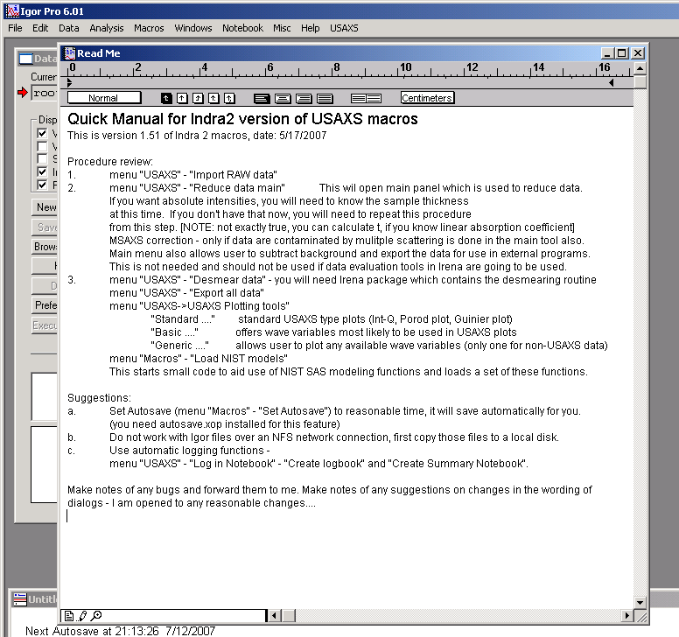

If you see what is in above picture, congratulations, you can start…

Data structure

The data structure for the Indra 2 version of macros has become more rigid and closely followed than previous version (Indra) of these macros. The name of the wave should now reliably indicate what data are in that wave. The further details about the wave are in the wave note. Together name and wavenote (which by the way contains also the name of the wave for cases when you copy and rename the waves) are fully explanatory… I was sick and tired of waves, which I had no clue about where they came from…

Data structure within Igor file:

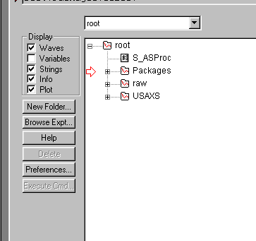
The data structure has three main folder areas, related to Indra 2 macros:

1. raw this folder contains full sets of Spec data, as imported. The data can be at any time – and any number of times – converted into USAXS data (if appropriate) or in another type data (Escan, Ascan, etc).

2. USAXS this folder contains the USAXS data.

3. Packages this folder contains working directories for the various procedures from Indra 2 macros set as well as from other Igor packages.

4. Modeling this folder is created by the interface macro for use of NIST SAS models. This is a user folder, where the user can do whatever he pleases… The data here are copy of desmeared USAXS data with names following NIST Center for Neutron Research naming convention…

NOTE THAT THE ONLY FOLDERS WITH USER DATA ARE THE USAXS & MODELING FOLDERS. DO NOT MANIPULATE DATA IN OTHER FOLDERS UNLESS YOU KNOW WHAT AND WHY ARE YOU DOING…

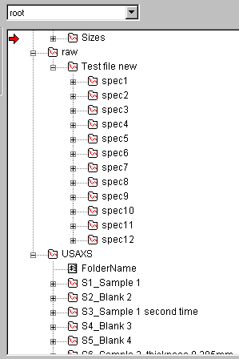
Here is the data structure in more detail for the two data folders.

Raw data folder:
The data are separated in folders called specXX, where XX is the spec run number. They can be within subfolder (as “IN2_Test file” folder in example). The subfolder name is by default proposed to user as the spec file name (IN2_Test file.dat). This folder name can be changed by user to anything reasonable.
The names of spec scan folders – “specXX” - should NOT be changed by user, since functionality of the macros will break… There is no simple way for me to protect these names, all I can do here is WARN you…
Comment: The raw folder is no place for user to do anything! There should be no need within routine use of these macros, when user would need to be here…

The raw folder, however, contains very important data – it contains all data from within SPEC file in more manageable form. It is place where to go if everything else fails…

USAXS data folder:
This is area with user data. Here the data are processed by the user using various functions and macros to obtain properly treated small-angle scattering data.
The data can be – but do not have to be – organized in subfolders here. The macros make assumptions: there is limited subfolder structure to one additional level. The most complex path to data is assumed to be :
“root:USAXS:SubFolder:SampleFolderName”.
The USAXS data are created by one of two conversion procedures, and the default sample folder name is formed from the spec number – SXX (where XX represents scan number from Spec run) - and from the first 20 letters or so of comment (hopefully sample name) used by user when setting up the USAXS run. The overall length is limited, so there is a need to have useful information in the spec comment at the beginning of the text, not at the end…
This is only the default name, user has full control of this name (using “Raw to USAXS one-by-one”).

NOTE:
Different folders can contain the same USAXS data!!! This is a FEATURE for user to be able to evaluate the SAME data in more different ways.

The folders can be named as user wishes (within Igor limits of length and symbol types), Indra 2 macros will make sure that the folder names do not duplicate… The folders can be renamed at any time with no directly bad consequences for user. The only one I can figure out is the fact that this step is outside the automatic creation of the log file environment such that the old records will be left with original folder name. However, the procedure will make comments into the automatic log, that the folders were renamed… There is no need to for the SXX_… in the beginning of the folder name. However, I think it is reasonable idea to keep it there.

Quick review of usual steps
Here I present short review of steps most users will need to evaluate data from standard USAXS runs. I assume that you do not need multiple scattering corrections.

- Get data from Spec file (or import data from Rigaku instrument) into the Igor.
- Convert USAXS data from raw Spec data. (usually started automatically)
- Create Rocking curve data (R data – Q, intensity, error), Subtract blank run from sample run, do the calibration if desired (smeared data [assuming standard USAXS] – Q, SMR Intensity and error).
- Desmear data to get pinhole collimated data (Q, DSM Intensity, error). This tool is now in Irena package. Download Irena package from usaxs web site, please…
- Plot and fit data to learn something about the material. Publish…

The macros can help you most of the way, except publishing… They cannot do that.

Note: There is no real manual for import from Rigaku instrument. It si basically transparent and should be intuitive. If it si not, contact me and I will create chapter.

This is brief and complex schematic:
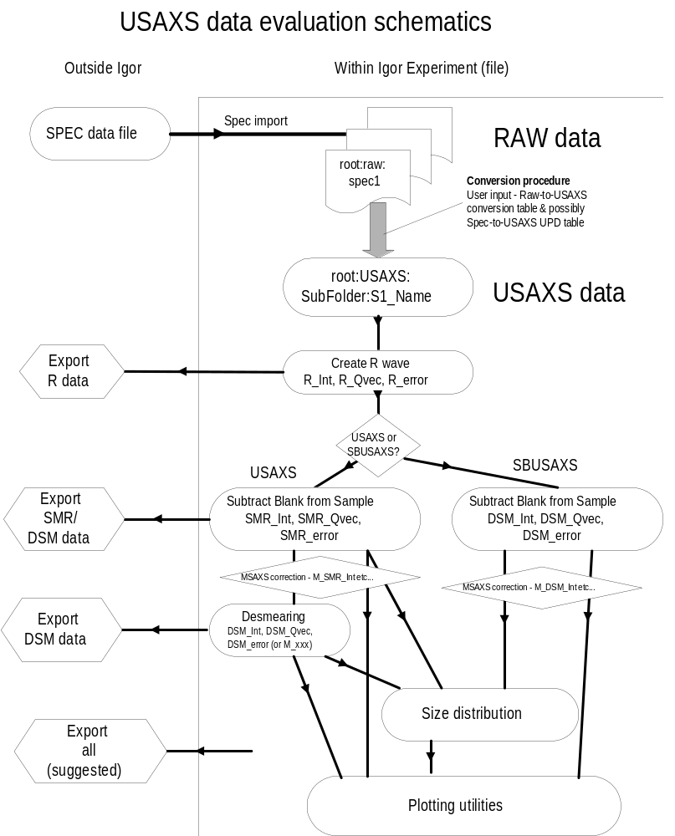
Currently done in 1 step
Automatic logging feature
Experience has suggested, that speed and ease of data conversion and manipulation results in troubles for users, because users do not make enough detailed notes (especially me) and then do not know what they have done… Therefore quite complex logging procedure was created. Automatically, when Indra2 macros are started logging notebook is created. This notebook is one of the persistent Igor notebooks, which cannot be killed, only hidden. Macros then make notes in this notebook, as they are run. Many comments in the notebook may be difficult for user to read, but believe me, I tried really hard to put in all details I thought could be useful. An example as proof – if user renames the folder, function run from time to time by some procedures finds this out and makes comment into the log notebook. Some user actions are difficult to catch – for example deleting folders – but that may be fixed in the future. I have some ideas…

Note, that user is free to modify the logbooks as wish… Anything can be added, deleted, modified in this notebook. Also this notebook can be printed or saved as rtf file… I strongly suggest users make as much comments in this notebook, as possible – or even better, open new Igor notebook and use that one for own comments… This is the best way to work, based on my experience…

The logbook can be anytime accessed from “Logging notebook” menu. The items in this menu are quite self explanatory, just note, that it is possible to insert in the notebook figures in color or in black and white… Really great feature, since the notebook saved as rtf file can be opened in Word (for example) and good quality graphs can be directly used for publications…

Using Indra2 macros

Getting data into Igor

Here we will get sample data from SPEC data file (IN2_Test file.dat) into the New Igor experiment. As mentioned above, this experiment should be included with the macros distribution and is called Indra 2 test.pxp.
But before the import itself, let’s ask question:

Which data are in the spec file?
Getting information about the spec data file is quite important and not easy. Therefore we have macro, which pulls out of spec data file comments and command lines, so user can check before loading data. This is especially important when the data file is really large or computer is slow.
In menu “USAXS”, submenu “Spec” select macro “Read comments from SPEC file”. Select data file:
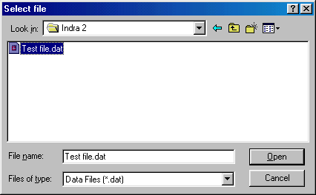

Following dialog customizes the macro run parameters:
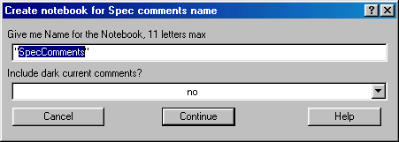
The data are inserted into Igor Notebook (see details prior in this manual). You can have large number of notebooks in Igor Experiment, so modify name into something useful, if needed.
Spec file may contain large number of Dark current comments, so it is advisable to select no here, if the dark currents are not needed.

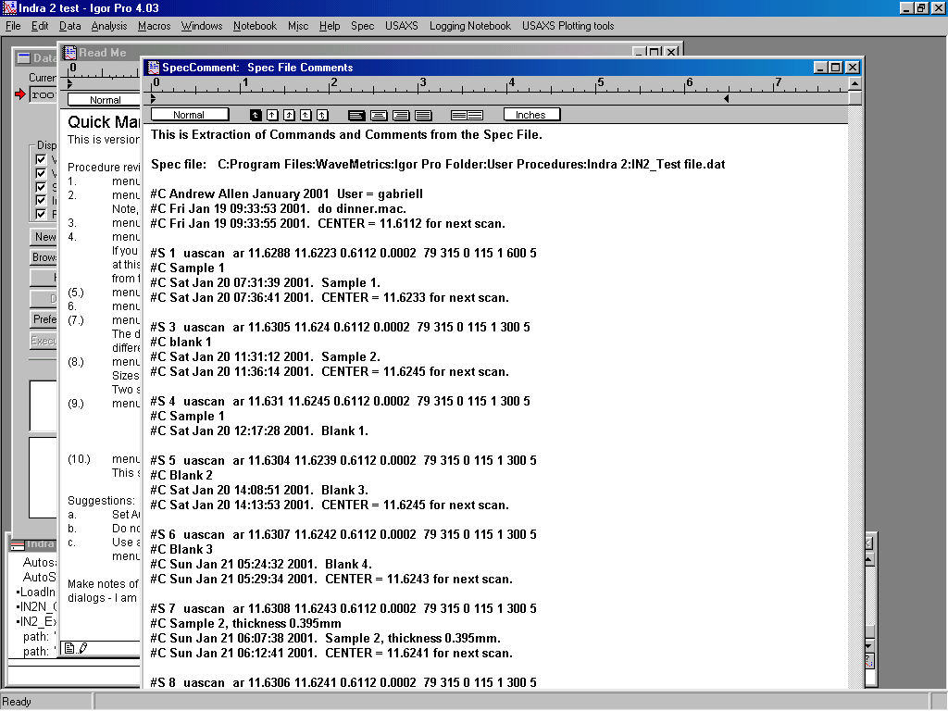

The above picture shows start of the data obtained. Short description:
First line has comment on what is in the notebook.
Next line has location of the data file from which the comments are obtained.

Next three lines relate to the header of Spec data file are not really important.

Line starting #S 1 shows spec command which was used to generate the scan. The USAXS data are created by uascan command (or is case of SBUSAXS sbuascan). Following are measurement parameters.
Next #C line has comment which user gave as sample name… Hopefully something useful and short.
Rest of #C lines until next #S line are comments during the run of one sample. Various numbers of those may be generated.
Minimize, export notebook from within Igor or close file as needed.

Importing data from SPEC to Igor

Select from “USAXS” “Import RAW data”. Select data file:
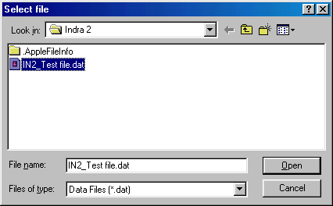

Following panel is presented:

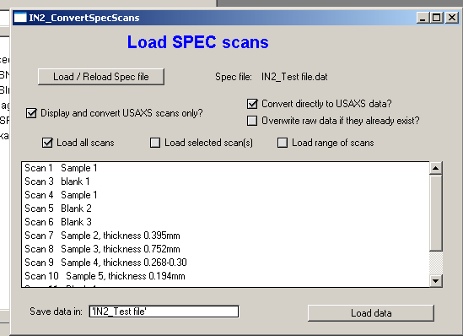

This panel allows to select which data are imported from spec file to Igor experiment. This routine is generic and loads ANY types of spec scans into the Igor experiment.

The controls/parameters are as follows:
- Button “Load/Reload Spec file” allows user to select different (or actually same file) to be reloaded. Current loaded file is listed next to the button. Note, that the listed file is currently cashed locally and unless you reload the file by the button, you will not get new data…
- Checkbox: “Display and convert USAXS scans only” allows you to select if the data listed and loaded are usaxs data or all data (including tuning macro).
- Checkbox: Convert directly to USAXS data – if selected the code will continue automatically into the “Convert raw data to USAXS”, and this will be called without any user further intervention with default values of parameters. Usually right ones…
- Checkbox “Overwrite raw data if they exist” will do as it says – if the raw data folder exists, it will be overwritten, no questions asked. Usually correct choice.
- Checkbox “Load all scans” will load all VISIBLE scans – therefore depends on the selection of checkbox “Display and convert USAXS scans only”… You cannot control the data in the Listbox.
- Checkbox “Load selected scan(s)” – allows user to select any combination of scans in the Listbox
- Checkbox “Load range of scans” – allows user to select continuous range of data to load.
- “Save data in” contains string, which will show the subfolder (under root:raw) in which the raw data will be stored. The “root:raw:” will be added, if not present.
- “Load data” button – will be available, if one of the “Load…” checkboxes is selected and then this will call further data loading procedures.

The panel can be killed as necessary and reused many times.

After first time (only the first time in particular experiment) loading data into an Igor experiment, it is necessary to setup “lookup table” which relates spec column names to USAXS wave names. Following panel is presented:
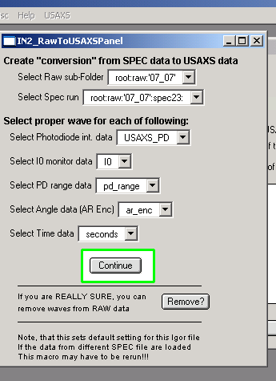
Note, that only the panel commands are active. First select in the first two pull down menus ANY data JUST loaded. The first pull down menu is likely set correctly. Set the second to ANY specXX name, for example spec1 or any other (spec3 here). It is not really needed, that it is USAXS scan, but surely is safer…
The purpose of this panel is to let macros know, which spec data columns contain the USAXS data, i.e., which Spec column name contains Photodiode intensity, intensity monitor, photodiode range, Analyzer angle data and time. The macros attempt to suggest proper parameters to be selected, so in each pull down menu the first item is the most likely item to be selected. However, the logic behind it cannot cover all possibilities.
Proper selection at this time is as follows, note that lately we name the photodiode counts as USAXS_PD or something similar:

Note, that this is one of the few “paper notebook” issues for user to note during experiment. The changes in the wave names happen accidentally. In 2001 and 2002 the USAXS_PD was used as name of the PD photodiode counts…

Leave “remove waves from RAW data” to properly instructed users… I went overboard with coding here…

Push button continue...

Note, that this created reference table for the macros to know, how the data columns in the spec file relate to USAXS data. This is always the same for data collected during one experimental run, but may change if data from different runs (different experimental times) are being loaded in one Igor experiment. This table then needs to be manually corrected for data loaded. ONLY one copy of this table is saved in the Igor experiment. We try to avoid changing the spec names, but it happens.
How do you find out, that things do not work right and the RAW-to-USAXS table needs to be fixed? If things do not seem to work in next steps and the data look like real junk, there is good chance that this table needs to be checked. The USAXS data created with wrong conversion table need to be deleted (NOT RAW!!!!), table needs to be fixed (“Spec” – “Fixes for conversion” – “Fix Spec to USAXS waves”) - make sure, that proper sample at the top of the panel is selected, and Raw-to-USAXS macro (any one of them) needs to re-run.

The following is the structure of data created by this procedure: Note the Logbook, which can be at any time opened by selecting “Open Logbook” from “Logging Notebook” menu. The notebook can be closed at any time – it cannot be killed. The macros are making notes there about what was done. Further note History are at lower end of the screen, where comments during import are written.
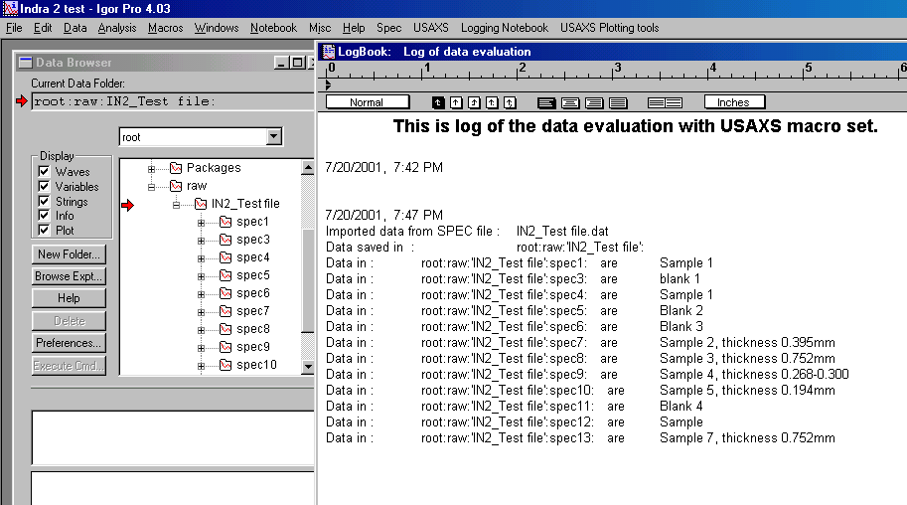

At this moment we have raw data imported into the Igor file.

Processing USAXS data – new method from March 2007

This is new GUI replacing many steps from the old method. The old method, described later in this manual is now obsolete, but available (in the menu is hidden in submenu “Old reduction”)

Using new method one needs to first process blank and then process samples. Any measurement can be processed as blank and also as sample.

GUI description:
Select “Reduce data main”

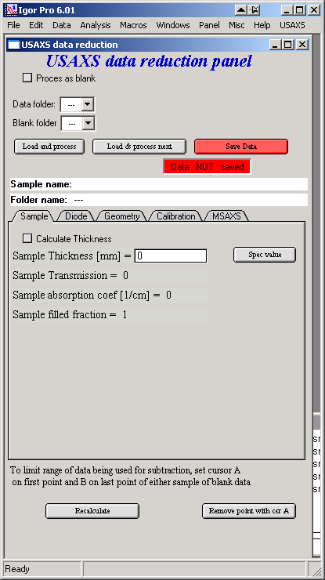
At the top of the GUI is selection is the processed data will be saved as blank (instrumental curve) or sa sample (blank required).
Below is selection of data – folder for data and (if not processed as blank) folder for Blank. Below are buttons controlling loading of data into the tool and saving data back to data folder. Information on Sample name and Folder name (cannot be changed). Tabs contain various types of controls and will be explained later. Buttons below control selected features and will be explained later.

Blank conversion

Check the “Process as blank” and select folder with USAXS data containing instrumental curve. Then push button “Load and process”:
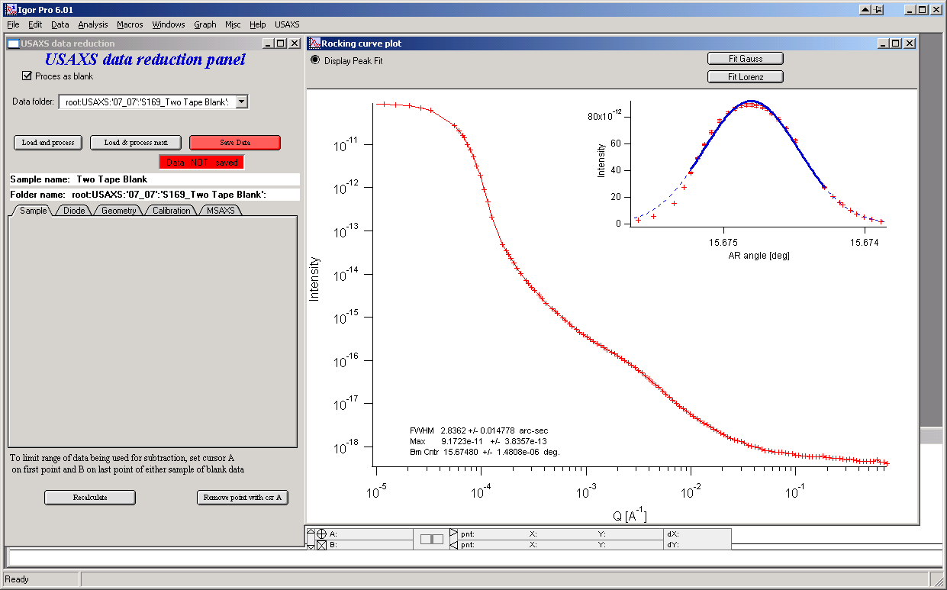

The data are loaded and graph is created… This is already resulting blank data, but following items should be checked:

- In the top right corner, is the fit to peak looking good??? If not, you can move cursors in this graph and refit the peak by using “Fit Gauss” or “Fit Lorenz”.
- Select tab Diode on the main panel:
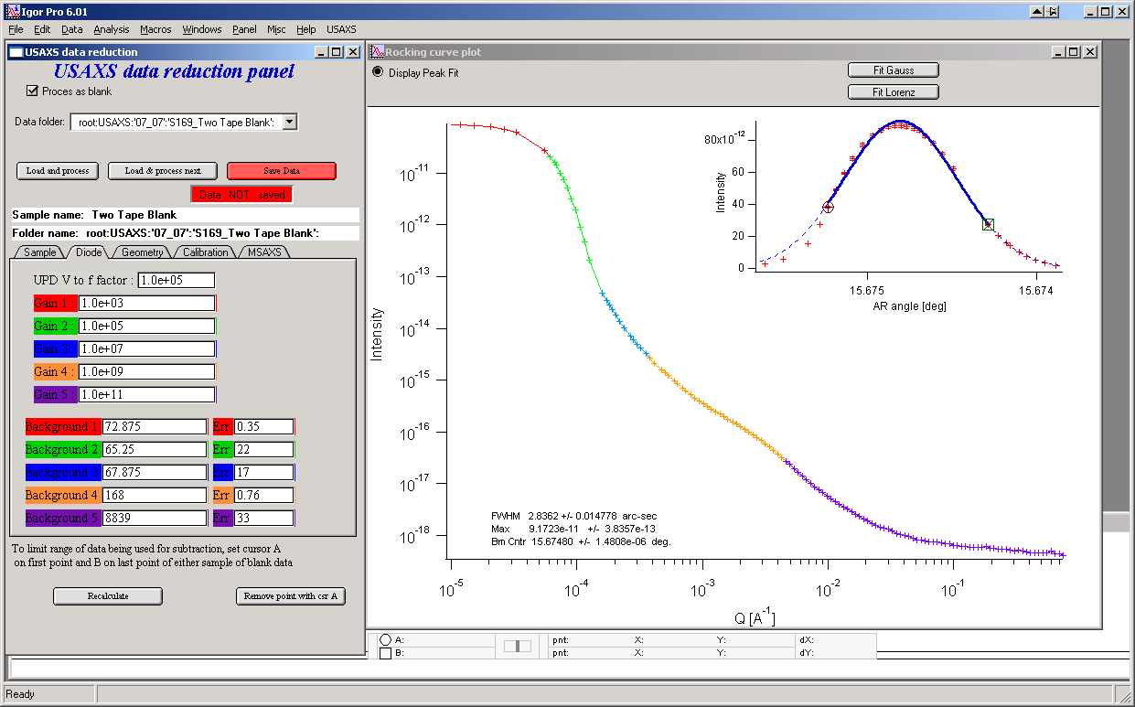
and check, that the diode ranges match reasonably well. Colors help identify the ranges. You can change dark currents (“Background” on the ranges if they happen not to match). Happens rarely…
- Check the Geometry tab :
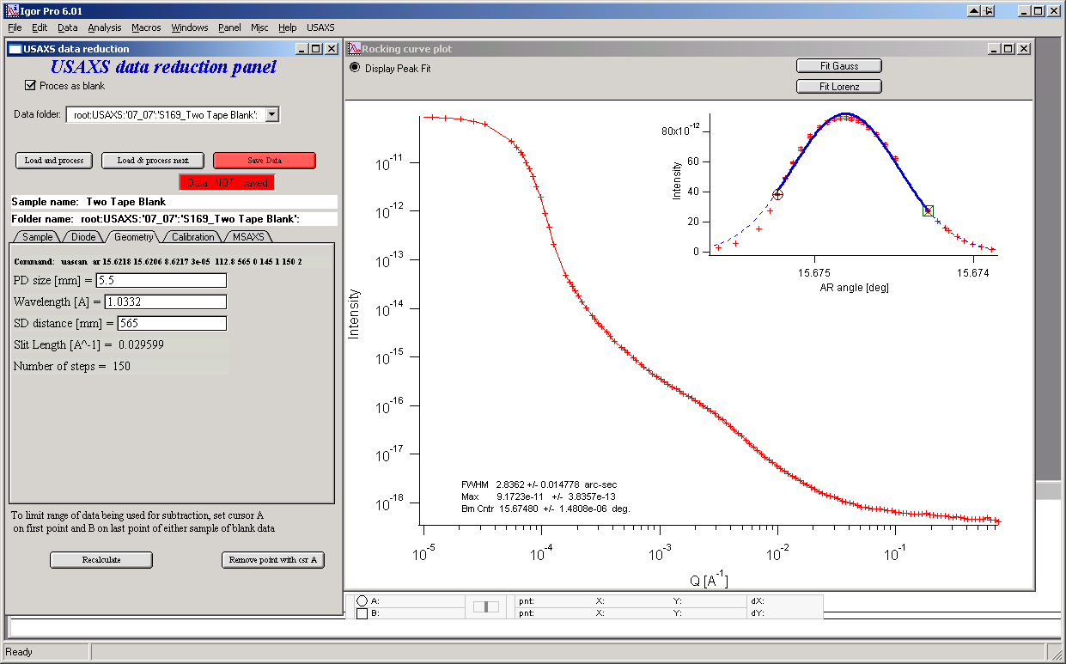
for measurement parameters, if they are right. They should be…

Basically this is all which needs to be done for Blank, push button “Save data” and it will change from red to grey, indicating, that data were saved…
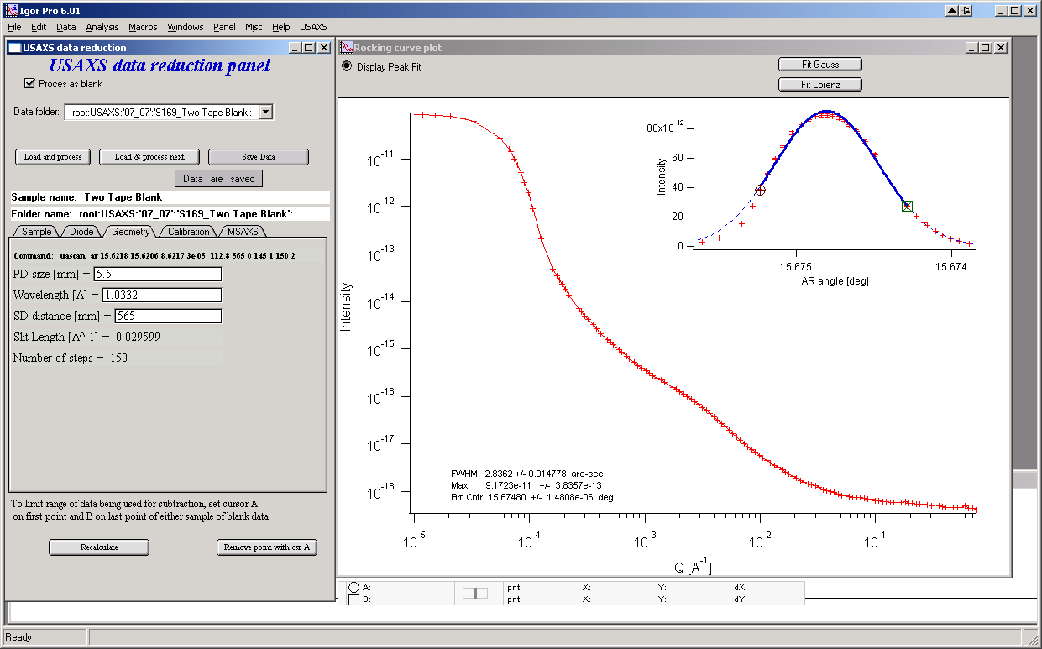

Processing sample

Uncheck the “Process as blank” checkbox.
Select sample folder in the top popup and blank in the bottom. Push “Load and process”. Data will be loaded and automatically processed the whole way to SMR data (for slit smeared USAXS) or DSM data (for 2D collimated USAXS). Any changes in parameters made by user later wil be automatically processed and results recalculated. So the data are in this way “live”. The only thing which is not processed automatically are changes in cursors positions in graphs on right (in the main graph and the insets), where user needs to push one of buttons…
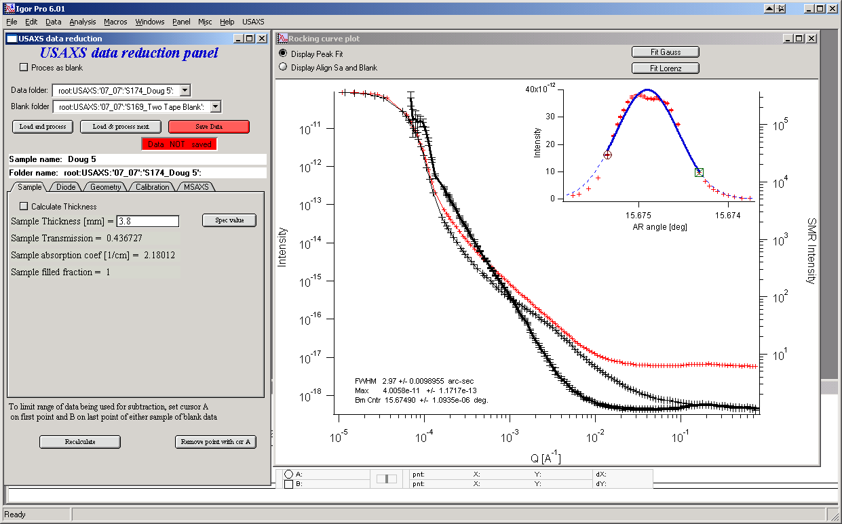

This is graph with processed data. User should check various items:
- The fit in the top right graph (note: the checkbox in the graph top left corner needs to be here “Display peak fit”). If the fit is not right, select different range of data and refit with Gauss or Lorenz and/or remove point (set cursor A (circle) on the point and push button on main panel “Remove point with csr A” – remove cursor B (square) from the graph first).
- Check the right thickness and overwrite if necessary. You can also calculate the thickness from known linear absorption coefficient (1/cm) and measured sample transmission. Filled fraction value is used to correct for known porosity value for samples.
- NOTE: The Sample transmission here is value obtained by peak-to-peak comparison with Blank corrected for any MSAXS correction, if selected on “MSAXS” tab…
- Check the diode ranges by selecting the “Diode” tab
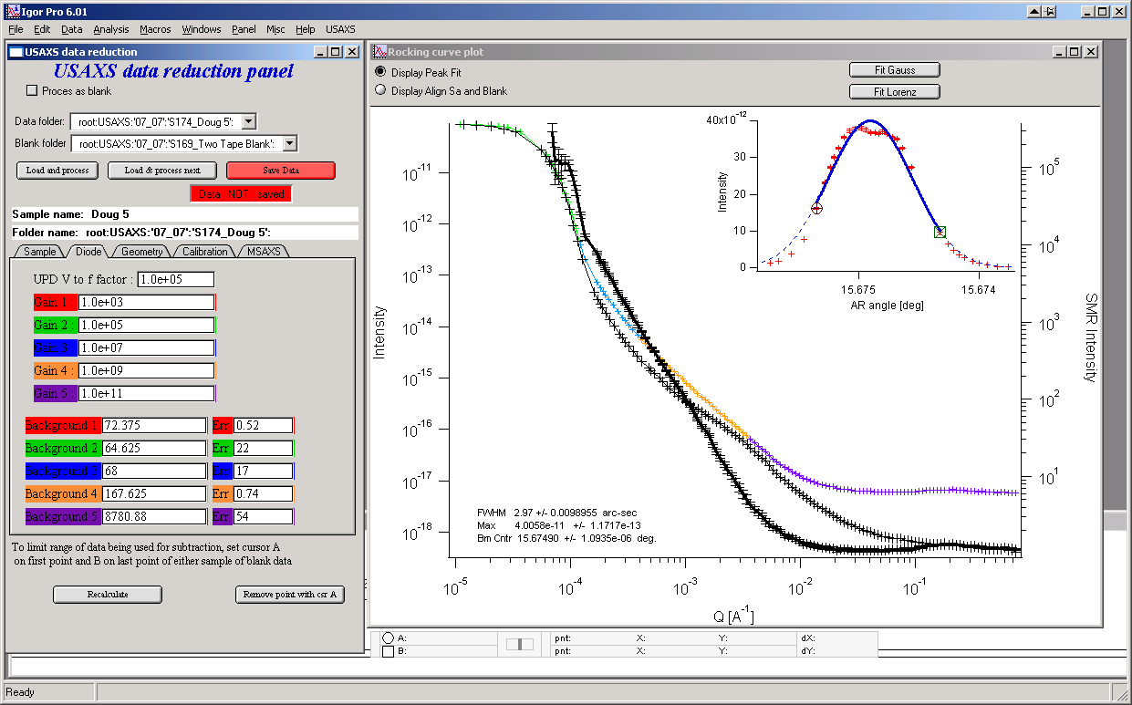
If the sample and Blank cross and the subtracted intensity is negative, it can be fixed by subtracting less of background from sample on range 5. This is correct fix and has no effect on data quality, as there will always be unknown amount of flat background left in the measured data.
- Check the peak-to-peak alignment by selecting the ckecbox “Display Align Sa and Blank” at the top left corner of the main graph. Note: it is the right top inset graph which replaces the peak fit. Sample is red and blank is black lines.
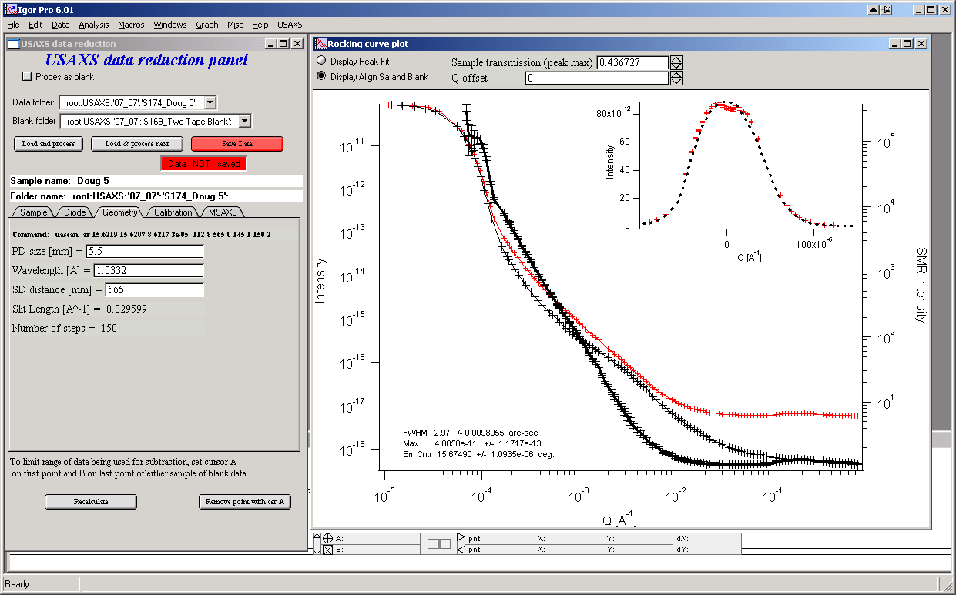
If the automatic routine fails, you can improve fit by changing transmission (align peak heights) and/or Q shift. Fails rarely. Especially the Q shift.
- Check the Geometry tab for parameters if they are correct (they should be).
- Check the “Calibration” tab :
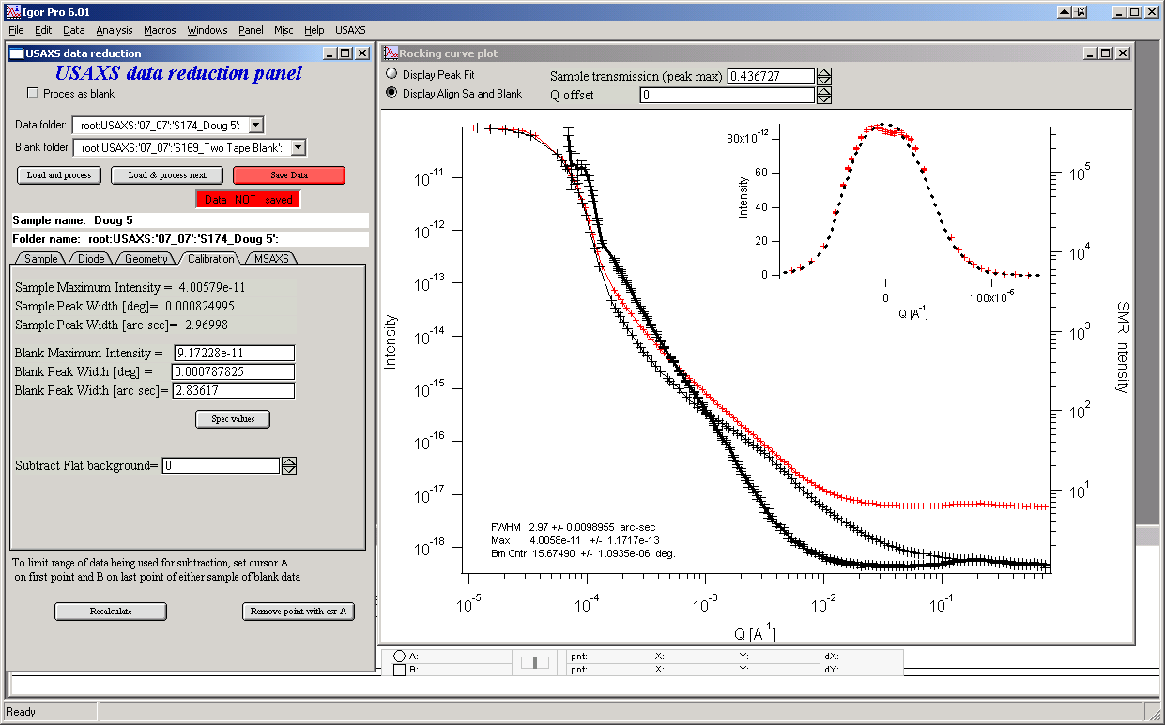
and compare the peak widths for sample and Blank (or compare visually the graph at the top right with the sample and blank peaks) to see, if there is any multiple scattering. If the peak for sample is more than 5% (about) broader, you may want to apply the MSAXS correction.
- Note, that you can also subtract flat background here from the data, in case it is important/useful…
- If Multiple scattering is present (not the case of sample used as example here…), select “MSAXS” tab and choose “MSAXS correction on absolute intensity” checkbox. This will present graph with the peaks for sample and blank. Note, that any changes of cursors in this graph are “live” and data will be recalculated immediately.
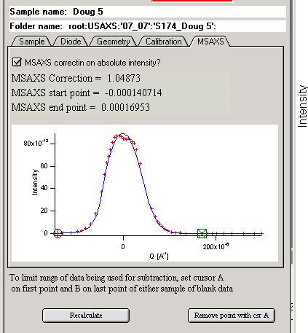
The numbers here are calculated from the integrations of the curves. The MSAXS correction is propagated automatically to the “Sample” tab and at this time the sample transmission on ths tab will not agree with the peak-to-peak value in the graph.
- You can set cursors on the main graph to min and max values of Q which should be used – set them on either Blank or sample curves. The position is retained when new sample is loaded. Only data between the cursors will be used for calculating of the resulting data. If you change position you need to push button “recalculate” since the cursors in this graph are not “live”.
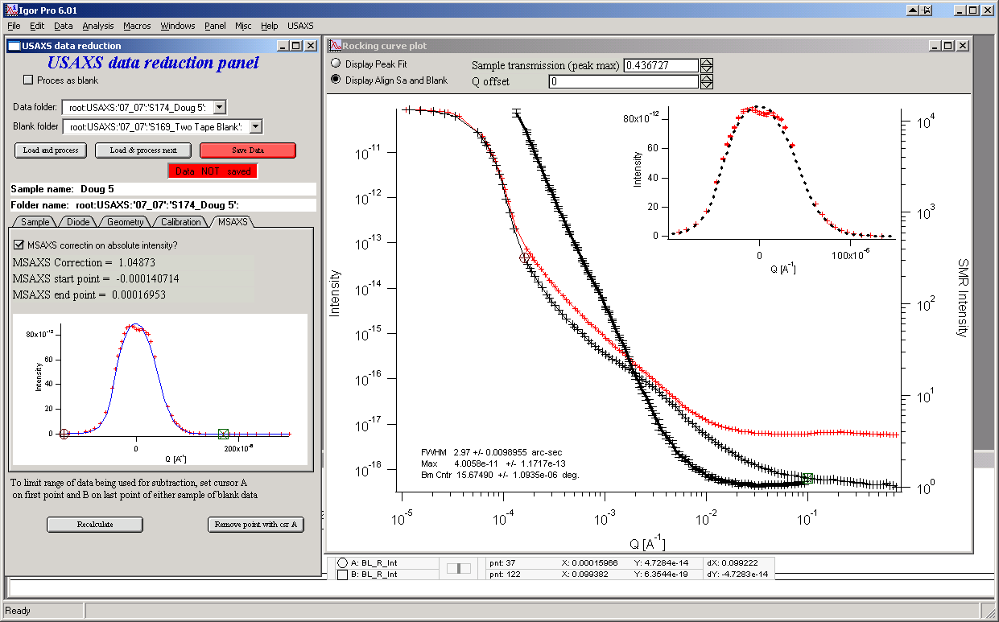
- Push the button “Save data” and all is done…
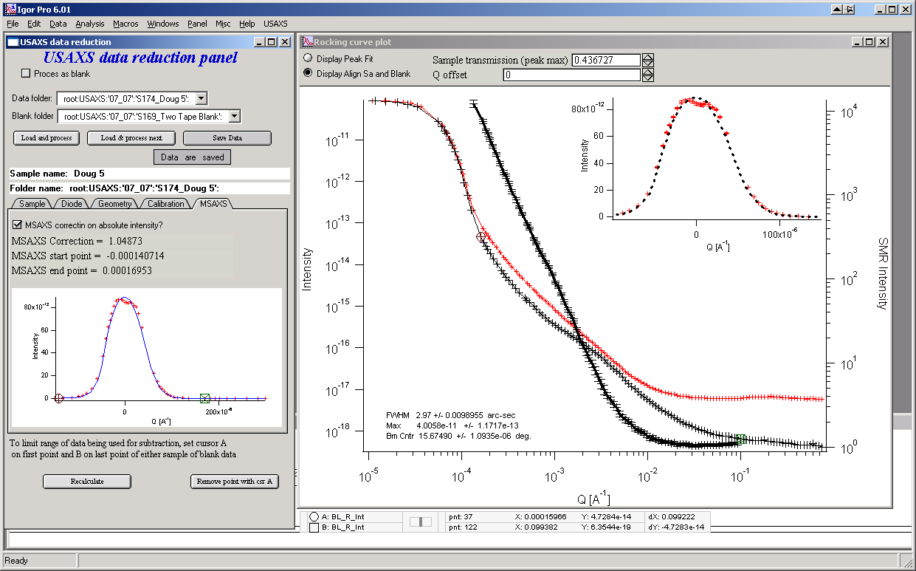

To process next sample in the row with the same blank, select “Load & process next”.

If the data are from slit smeared USAXS they may need to be desmeared – the tool is now part of Irena package – download the package and read the manual for the desmearing routine.

Using model intensity to estimate USAXS signal

Very important question, often raised about unknown samples and USAXS instrument is, if the scattering from the sample will be detectable for a given sample or not. This is related to the unusual USAXS feature – that it is practically impossible to change sensitivity of this instrument. Increasing exposure time makes generally no difference and there are very few methods to improve sensitivity (if you know about any, let me know, please…)

Anyway, so I often get question, if system, which we can describe – or measure on another instrument – will be measurable on USAXS – either slit smeared or 2D collimated. This tool is here to answer this question – or at least give us some estimate.

What you need:
Calibrated (1/cm units) Intensity and associated Q. This can be result of previous measurement on USAXS or another SAXS/SANS camera (SANS data need to be scaled by ratio in scattering contrasts) or result of one of the modeling tools in Irena package. Sample thickness and estimated transmission.

What you get : Approximate difference from instrumental curve at basic energies build in the tool. For now 12keV and 18keV, both slit smeared and 2D collimated.

Using the tool
Select “Calculate Scattering from model” in USAXS menu:
Data selection: at the top, select data you want to for model. This can be USAXS data, qrs data or Irena model. Remember to pick sensible model - that is Intensity/Q vector pair, not size distribution. At this moment no attempt is made to check for this and avoid user selecting meaningless input.

Then select Energy to be used, estimate transmission and sample thickness. Select geometry and you should receive following graph:

Note selected data are results of model. In this case I modeled using USAXS desmeared data, therefore when I want to model USAXZS slit smeared I also need to smear the data. Slit length 0.04 is good estimate for usual setup.
I estimate that the transmission is 0.5. If you need to estimate the transmission, use Anomalous scattering calculator from Irena package. It can calculate very good estimate for transmission.

Sample thickness is in mm.

In the graph you see blue dotted line with original model intensity (against right axis). Then Black is instrumental curve and red is estimated USAXS measurement – after scaling the sample and balnk together by 1/transmission for easy understanding how much your sample scatters above the Blank.

Note, that in general to get good data, you need at least factor of 3x above the instrument curve. Anything below is marginal and anything less than factor of 2 is usually bad… 10% is useless… Remember, the axis are all log-scale!!!!

Rest of this manual is informative but likely obsolete (yet mostly valid and may be useful)… You should not have to read it.

Photodiode conversion table
The spec data contains large block of data related to the photodiode. These constants for given experiment (gains, v-to-f factor, etc) or are measured each time before USAXS scan (backgrounds) and are used for data evaluation. These data are pulled out automatically from the spec file. However, on rare occasion it is possible that the naming assumption which I assume may fail (especially at this time for very old spec files). This names lookup table can be fixed in the “Spec” – “Fixes for conversion” – “Fix Spec to USAXS UPD”. Currently the correct setup should be:
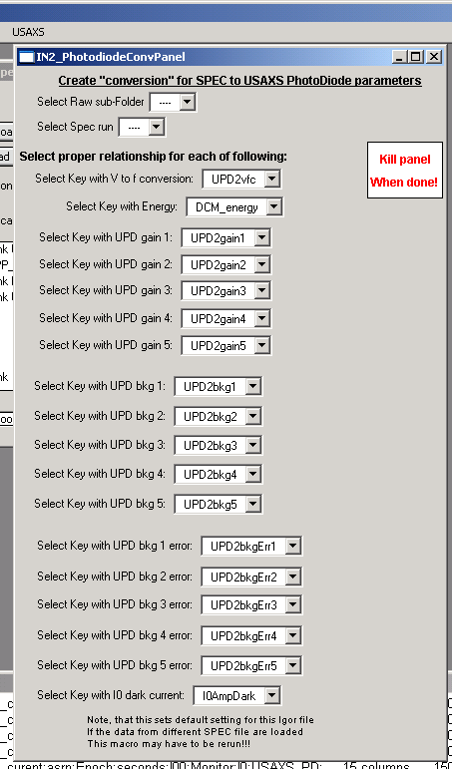
Again, wrong setup of this table will cause junky data in the following steps… Problems here more or less suggest a phone call to me or Pete… They should not happen for data obtained starting in year 2000, so most users should not have any troubles…

Creating USAXS data - NOTE: this is usually done on load of data and is not necessary to do again by user, unless special circumstances happen…
There are two main paths how to create the USAXS data. Most users will be most happy with “fast” method, which allows processing of group of raw data into USAXS data at the same time. For others there is “slow” method, which allows conversion of one scan at a time.

Standard method

The standard (aka fast) method is automatically started after loading spec data, unless user selects not to do so… If it is not started automatically, then select from “Spec” choose of “RAW to USAXS quick”.
The following happens only, when started manually:

Select subfolder, in which the data are present. If the subfolder does not exist, this prompt is skipped. Note, that this method needs to have all scans to process in one subfolder.
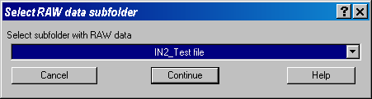

This now happens in all cases:
Next select, which method you want to use. There are two possibilities. “Range” or “Last Loaded”. Range is clear – select Range and then start and end scans. “Last Loaded” is default and is somehow special… The macros do have list of scans which were imported into the raw folder during last run of the import macro. Assuming that this is still the proper subfolder in which the raw data were last imported, the same data will be converted into USAXS data. This can be very convenient function, because user does not have to remember which data were last loaded…

Assume we want to download range of scans 1-13:
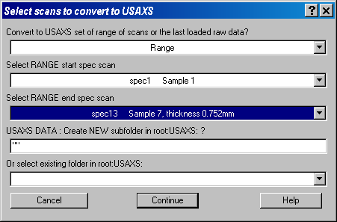
Before continuing user needs to decide, if he/she is interested in putting USAXS data in the subfolder of the “root:USAXS:” folder. This may be useful if various data are to be processed at the same time…
There are two options which need to be set. Assuming the subfolder in the “root:USAXS:” user wants to use does not exist, the name of subfolder needs to be typed between the quotes. If the folder exists, it can be selected from the lower popup menu.

For this test file following was selected
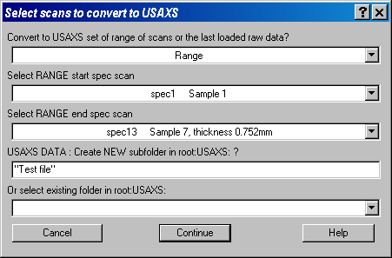

This resulted in following data structure and list of comments in the Logbook
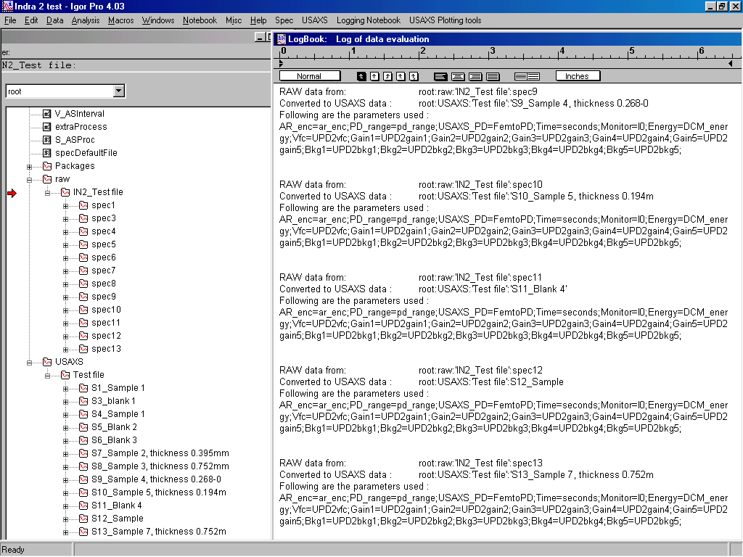
Note, that the logbook contains what raw data were converted into which USAXS data and also list of parameters used for this conversion.
Following data were created in the USAXS data folders:
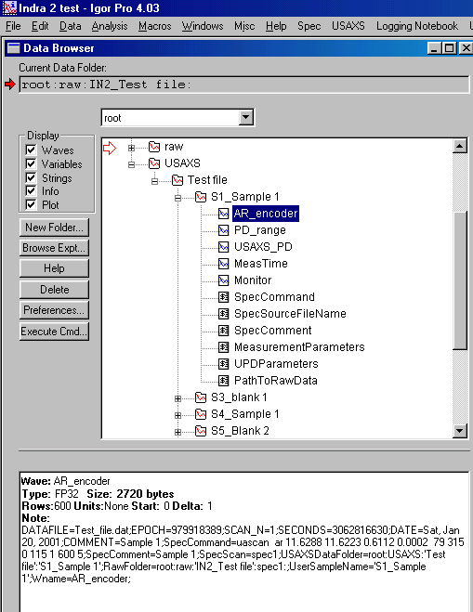
Note the wave note in the lower window. This note is attached to each wave created by these macros and is routinely updated. It contains most of the history of the data – what has happened to the data to get here…
Following is the list of items in the USAXS folders:

WAVES:
AR_encoder A stage angle in degrees (encoder values)
PD_range PD amplifier range (numbers 0-4 for FEMTO amplifier)
USAXS_PD PD counts at each range
MeasTime Measurement time in seconds for each point
Monitor X-ray beam monitor counts (Ion chamber counts) for each point, used for normalization.

VARIABLES:
No variables…

STRINGS:
SpecCommand String used to run USAXS run in spec, contains measurement parameters
SpecSourceFileName Name of SPEC file name
SpecComment First comment in SPEC file for this run, should be sample name
MeasurementParameters SPEC measurement parameters, energy, etc… Pulled from Spec file.
UPDParameters UPD parameters – dark currents, gains, etc. Pulled from Spec file.
PathToRawData String with path to RAW folder from which the USAXS data were created.
FolderName Auxiliary string, do not change.

Slow method
This is method which allows user full control of the process of conversion of raw data into USAX data. The logic is same as the one of fast method, but uses a crowded panel with large number of parameters, which can be changed. I suggest using this in special cases, when user needs to convert just one – or few – raw sets into USAXS with full control. Play with it and test the capabilities, it is really a complex piece of code…

R data creation
This first step in the data evaluation is creating Rocking curve of the sample (blank). During this procedure the angular data (AR_encoder) and USAXS_PD counts (with range info) are used to generate the Q values and intensity in counts. The angle of beam center is found and set to Q=0 and the PD data are corrected by range info and dark current info to correct for amplifier gain and changes…

Lets walk through this procedure for one run:
Select “USAXS” – “Create R wave”.
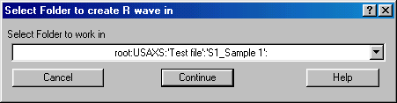
Keep the selection. Note, that as you proceed through the data evaluation, the present folder in this menu changes to next folder…
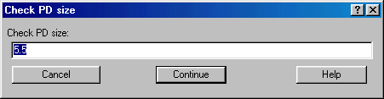
This dialog appears only the first time in Igor experiment. This would allow change of the PD size, if different PD was used… Up to now we have never used different PD, so this value is set correctly. Unless instructed differently, do not change…
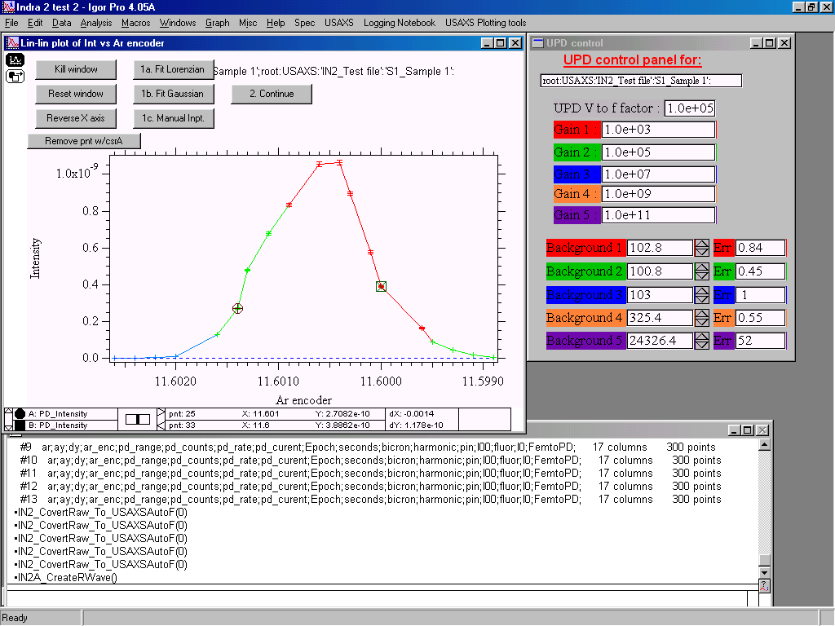
This is the first graph of this procedure. Here the user needs to find center of the beam. There are three methods, which can be used 1a, 1b, 1c… The most likely appropriate is 1b – fitting Gauss function between the cursors. Using 1a Lorenzian function may be also useful sometimes, especially in SBUSAXS… For special cases only is the manual 1c method…
Move cursors around as needed, so the function reasonable well describes the peak… Note that both peak center and peak height are used in the following procedures, so the fit needs to be reasonable…
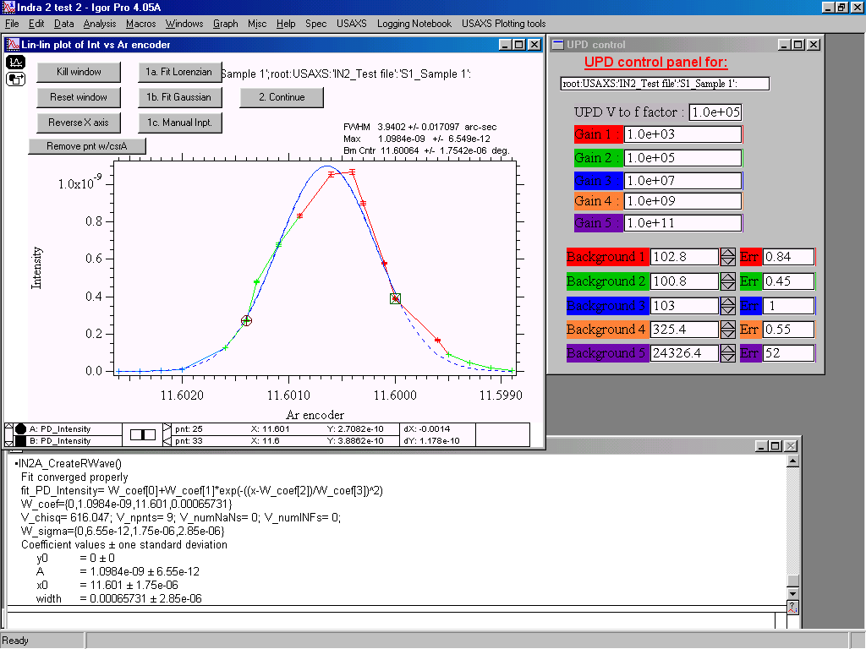
This is result of the fitting – solid blue line indicates fit between the cursors, dotted blues line shape of the fitted function outside the fitted region…

If you get message about weird cursor positions and differently looking graph (with steps etc):
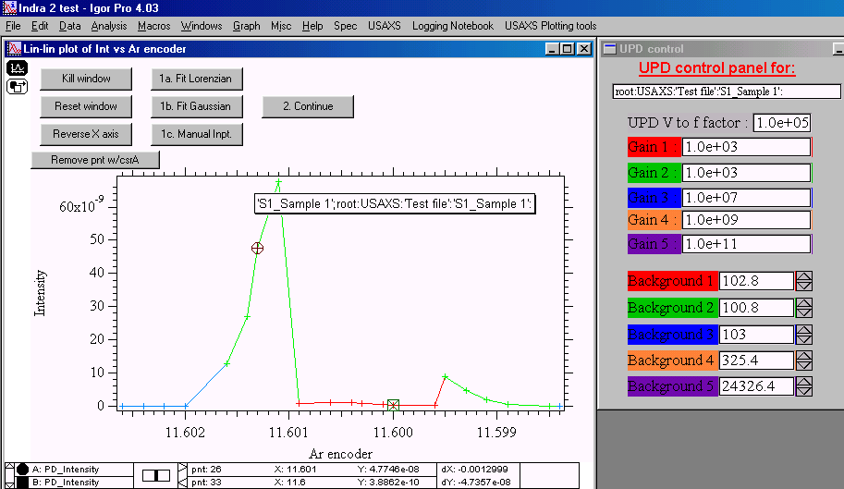
Then this is likely caused by problems in setting up the data in the panel on the right - those are photodiode amplifier data. This can be caused by wrong table setup as mentioned before. It can be fixed here manually (note that to demonstrate I changed Gain 2 from 1.0e+5 to 1.0e+3), or by deleting the USAX data and changing the lookup table (Fix Raw to USAXS PD)…

Lets continue:
This particular run belongs among the more difficult ones to fit, but lets accept following fit
Move the cursors around and push the 1b button. You may have to move the legend in the graph to see the top part of the curve… Note, that the text box in the graph now shows the full width at half maximum, maximum height and beam center in degrees… No need to make notes, the macros will make them shortly in the logbook and wave notes… When satisfied, push button 2. Continue.
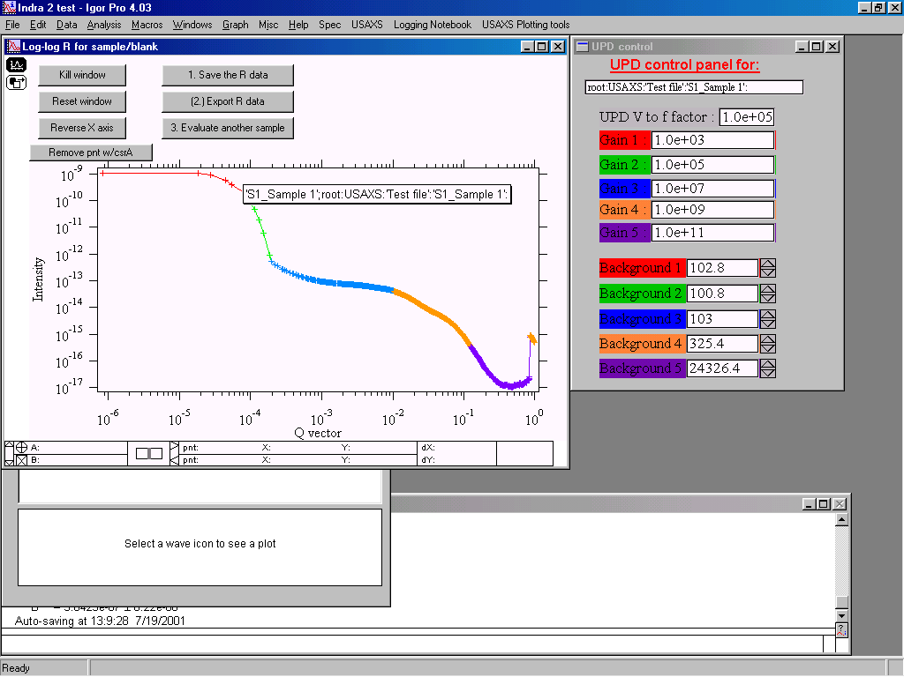
This is second graph of this procedure. This one is here mostly to check the background for each range… Note that ranges of the data are marked with the colors, which are also used in the panel to aid user. This graph can be zoomed in and out as needed using Igor commands to check how ranges join together.
Let me demostrate problem with background:
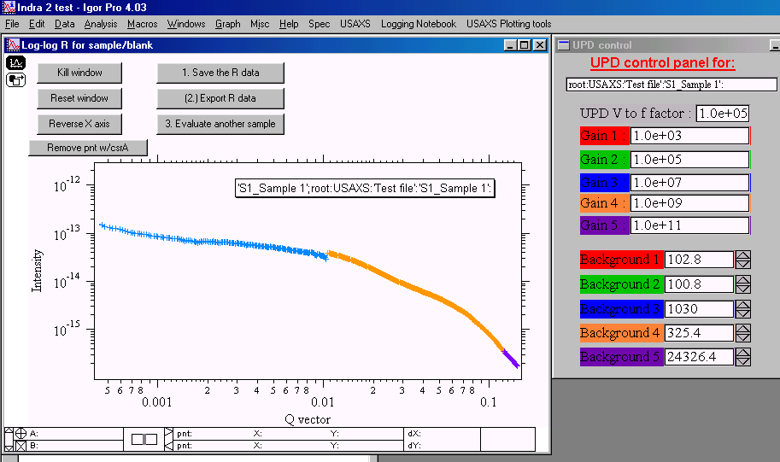
Here I have changed background 3 from 103 into 1030 and zoomed in the area, where range 3 and 4 merge… Note the discontinuity. Lets try changing the background into 103 again and zoom in some more…
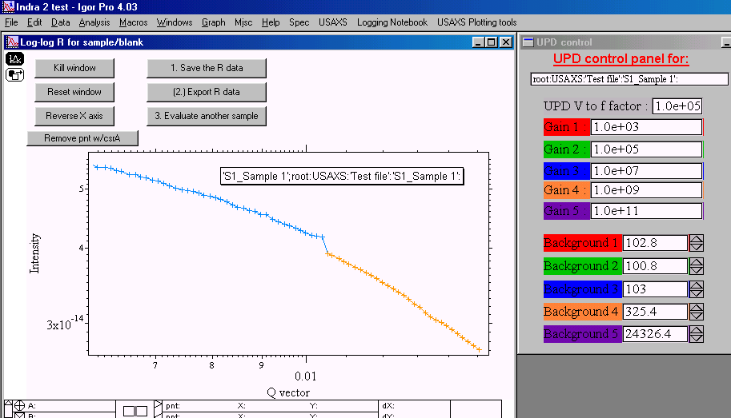
Note that there is still some discontinuity… Changing the background 3 into 250 fixes this discontinuity:
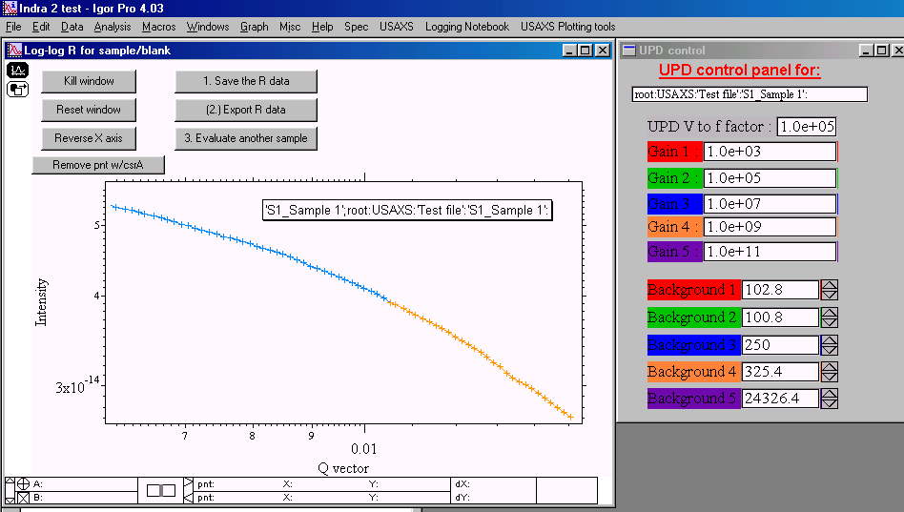
This the proper value for the background 3… Similarly one should check the other backgrounds (there is no way to check the background 5)… It is IMPERATIVE to work carefully here, because wrong background setting here will propagate through the data evaluation procedures further and get amplified. It can reduce usefulness of the data significantly…

Relatively acceptable values for backgrounds are in the following figure:
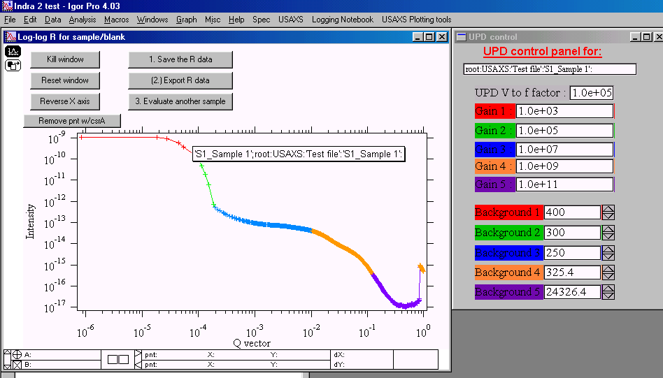

When happy with the backgrounds, we can continue. It is possible here to remove apparently bad point with the button “Remove pnt w/csrA”. Note, that Igor cursor A is the rounded one. Only cursor A can be in the graph… When done push button 1. Save the R data. This will create in R_Int, R_Qvec, and R_Error waves in the appropriate USAXS folder. Note, that this also takes away the panel, as changing any values in it would not influence the already saved R data. If you need to change the R wave you have to rerun the Create R wave procedure on the same data.

Note, that if you forget to save R data and attempt to continue with another sample you will be warned and given opportunity to fix this mistake (if it was mistake):
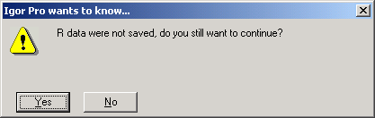
This warning is not presented if you attempt to do end the procedure by other methods (kill window)…

It is possible to export now from Igor ASCII file with three columns of data (Q, Int, Error) by pushing button 2. Export R data, but I suggest using another procedure when done with all the steps in Igor.
Lets check now the logbook:
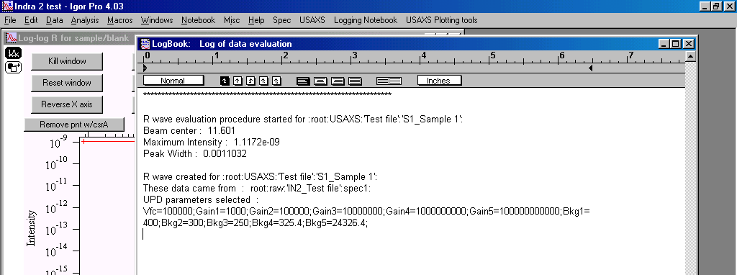
Note, that the macros wrote all important in the logbook – fitting parameters, UPD parameters etc…

Further one can continue with another sample (button 3. Evaluate another sample) or end with this procedure (Button Kill window, or just kill the window)…

Lets finish up with the other scans on our own, so we have data to use in further steps.

Subtracting Blank from Sample
Next step is to subtract instrumental curve (usually we call it blank) from the sample measurement. Select “USAXS” – “Subtract Blank from Sample”:
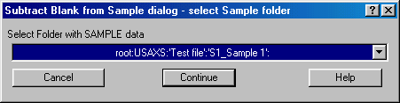
Select sample 1 as in this figure. Continue:
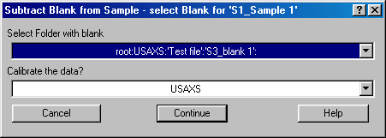
Select blank 1 and keep Calibrate as USAXS. The other options are SBUSAXS (selected automatically, when appropriate) and none. I suggest always calibrating, since the only input the user needs is sample thickness (rest are instrumental parameters) and even when the thickness is not known, this procedure takes out all the other changes of this instrument and makes comparing samples together easier…
Continue:
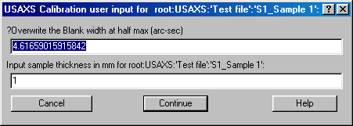
Calibration parameters. Unless you know otherwise, change only the thickness, the first parameters is for special purposes… Thickness may be set correctly, if it was included in the in the spec file. We have included this in February 2002.
Continue:
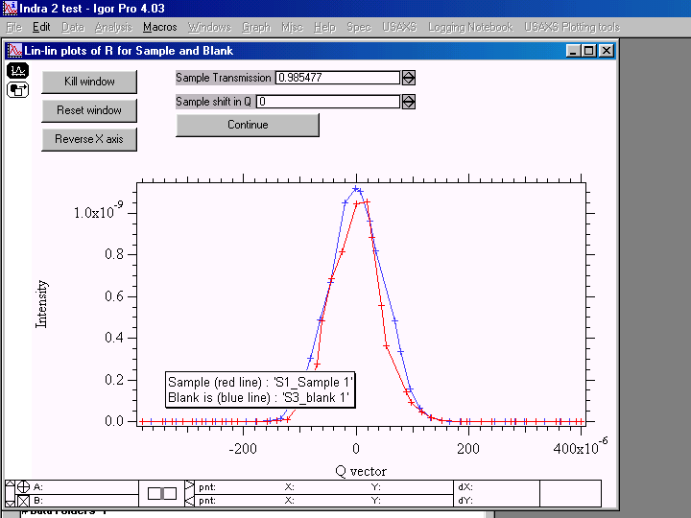
This graph is for aligning the peaks so their center and height are aligned. The pre-alignment is done using the fitting parameters, so it is usually done well. If you do not like it, you can change the alignment using the transmission (should be always smaller than 1!) or sample shift in Q (should be really small number)…
When satisfied, return to original transmission and Qshift=0 in this example and push continue:
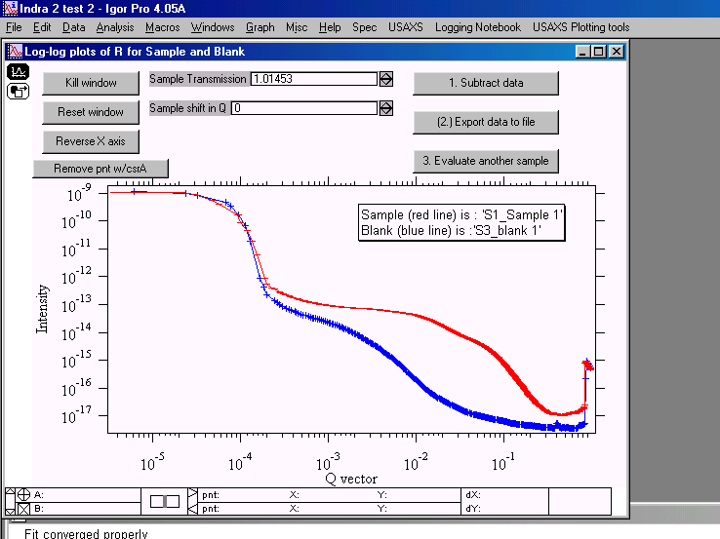
In this graph you can check log-log plot of both sample and blank and still modify Qshift and transmission. Modifying Qshift is unlikely here – the readout in log scale is poor, but it may be sometimes (rarely) possible to modify transmission. When happy, push button : 1. Subtract data
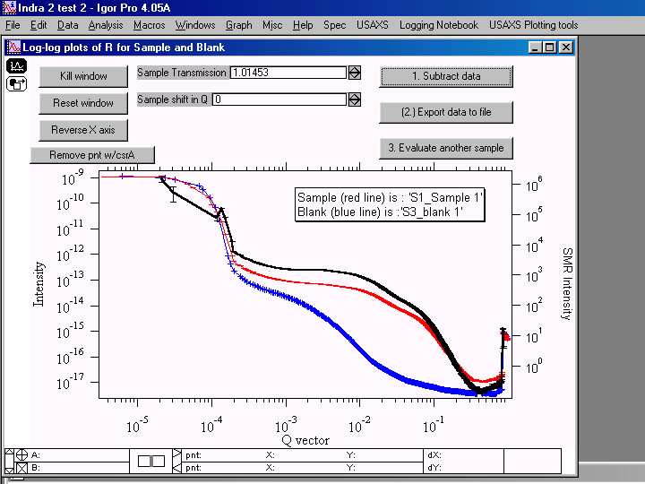
Note new black line in the graph, plotted on right axis. This is subtracted sample and blank, for regular USAXS these are smeared data. If the data were calibrated and the thickness of the sample is properly inserted, these data are in cm⁻¹.
It is possible here to export the smeared data , but as in case of R (rocking curve) data, I suggest exporting all at the end of the data evaluation in Igor…
Next we can continue with the other samples (not blanks) or end – do the rest on your own, using always the closest blank to the sample… If you do not want to continue, just kill the window using the button and the procedure ends. Note, that some samples do have their thickness in the sample name – good practice if possible – in the Igor sample file I have used thickness 1mm for all samples, which do not have the thickness in the name and thickness from the header, where it is available…
Note, that the logbook contains record of the activity:
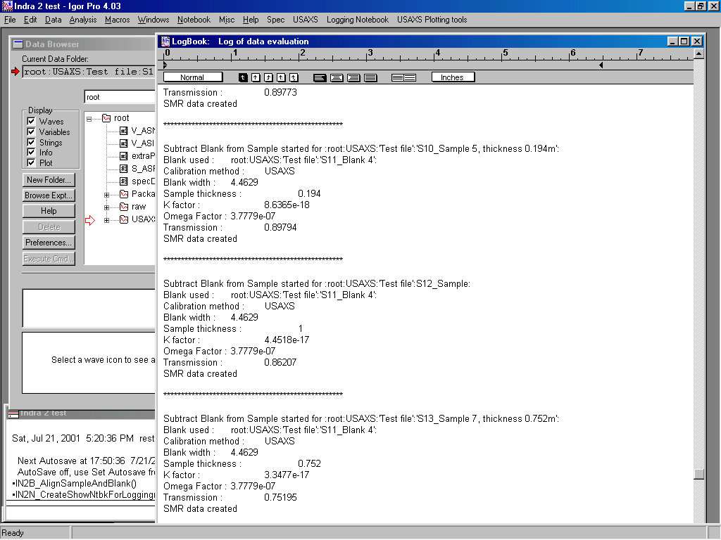

Desmearing
The data from the Bonse-Hart camera of standard type are smeared by slit width – another words, in one direction (vertically) the Q resolution is very tight (defined by the rocking curve width of the 6-bounce channelcut in our case), horizontally the Q resolution is defined geometrically by the width of the photodiode, wavelength and sample to detector distance. This is not the case for 2-D collimated USAXS - setup of Bonse-Hart camera with side reflection stages to provide “pin-hole collimated data”. There, the beam is collimated in both perpendicular directions by channelcuts and the Q resolution in both directions is very high.
To convert data from slit smeared geometry into standard pin-hole type data the Indra2 macros provide implementation of Lake method (reference).

The desmearing package has been moved to Irena code, including applicable manual. Please, download the Irena code and read manual part related to it…

Size distribution
Size distribution code has been significantly modified and moved into the Irena code. Please, get the whole package and use the manual included in that package.

Exporting data
Very important routine… First warning – this is automatic export tool, it is designed to export all different datatypes in ASCII form, which it finds in USAXS data folder subfolders… It will overwrite any files in the folder on the hard drive you give it (if the y have same name). Give it clean empty folder for data export, unless you know you will not need the data in there.
This macro creates complex, and long, filenames to provide as much info in them as possible. It works better on PC, where there are more spaces in the filename available.
Lets try an example. First create new empty folder (desktop is fine place for this folder), then select “USAXS” – “Export data” :

Next few questions:
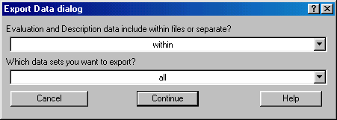
Evaluation & description data are basically the wave notes attached to each wave - they contain the whole history of the data evaluation… They are very valuable for future use. They can be included in the beginning of each file (within) or as separate file (separate). Make wise choice here based on your future needs. You can export one type of data sets (SMR or DSM or R or whatever else) – or all which exist in that folder…
Lets try to export all with the Eval & Desc data within.

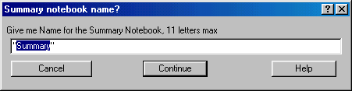
Igor will also create summary notebook, which can be then saved with the data to show what was done with the data to get them into this stage… Note, that the code will try to force saving this notebook in proper place and with proper format:
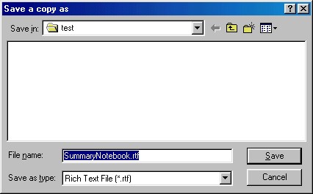

Now check the contents of the folder where the data were exported. The files should contain important data in form useable by other programs…
Note, that to keep names length under control, the names were shortened. Also note, that extension now indicates, what data types are in the files.

Importing X23 data
It is very unlikely anyone except me and few close collaborators will ever need this routine. There is no documentation for it at this time…

Plotting tools
There are three different plotting tools available in the Indra2 macros. They were developed subsequently and anyone can provide basic plotting of the data obtained during data evaluation… Their choice is really based on users taste.
The only plotting tool really general and fully flexible is Igor itself. Igor can produce nearly any graph user wants – assuming user is capable of using Igor to its potential. Major problem which user is facing are the datafolders. Navigating data folders – and making useful legends for the graphs, since the sample names are in the data folder names and in the wavenotes, is the reason why the user needs to be quite Igor proficient. All Indra2 macros are trying to handle the data folder structure transparently for user.
Note, that all of the plotting tools were developed only to display data of one of standard USAXS data types, such as R-wave, SMR wave, DSM wave etc. There is no tool for displaying different data types in one graph – you are on your own, if you want to do so…

Plotting tools do not make any notes into the logbook… Does not seem to make sense. And also note, that since the data are usually copied into special folder (in root:Packages:) one cannot use “save recreation macro” routine from Igor to save the graph for future use. On the other hand, the macros can freely modify the data in the plot without modifying the measured data in the original folder.

USAXS plots with math
This is the most complex – and most complicated but capable – plotting tools. I suggest trying this one first. Also this is the only one I intend to develop in the future.
This tools can:
Display two standard graphs of the same data
Do simple math – such as multiply intensity, subtract background, limit Q range to each dataset separately
Do simple fittings (Porod, Guinier) and display fits in different plot types
Handle, I believe, up to 20 data sets. While the datasets cannot be removed, they can be made invisible in the graph…
Another words, this tool was designed to be as flexible as possible.

Warning: This tool routinely redraws the graphs from scratch, so any customizations are lost when data are added, removed, axis are modified etc. Keep this is mind when making custom changes to the graphs.

This tool uses separate folder in “Packages” to keep copies of the data. It has to be done this way, since this tool needs to be able to do simple math with the data. The tools uses more flexible interface with panel… By the way, to end using this tool, just close all associated windows and the panel…

Types of data which can be ploted:
R_wave “raw data” reduced intensity vs q, before blank subtraction.
SMR slit smeared data (before desmearing from 1D collimated USAXS)
DSM desmeared data (after desmearing or from 2D collimated USAXS)

Select “Standard USAXS Plot” from “USAXS plots” menu, you will get following panel:
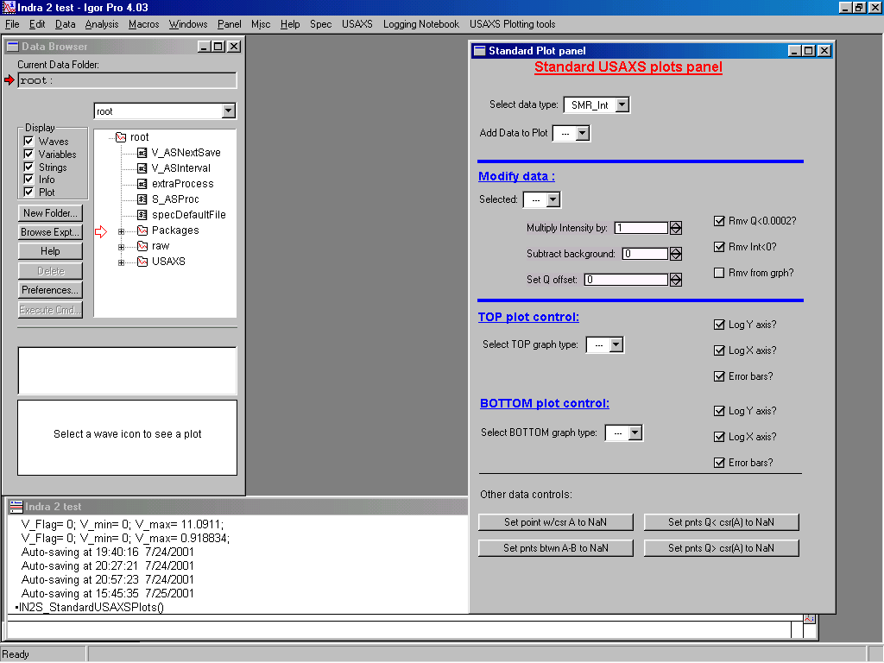

Description of areas in the panel:
- top part - selection of the data type (each change here resets the whole tool and needs to be confirmed by dialog). Selection of data in the pull down menu. When data are selected, they are automatically added into the list. Same data can be added multiply. I believe that 20 datasets can be added, the data sets cannot be deleted, just made invisible…
- Modify data part. The data set can be selected from the pull down menu and then modified. The macro remembers all modifications made to each dataset and when returned to previously modified dataset, the proper numbers are shown. Note, that it is possible to multiply the Y axis (“intensity”), subtract background, change Q offset (X-axis offset), remove points (set the points to NaNs) for negative intensities and for intensity values (Y axis values) smaller than 0. Also by selecting lower right checkbox one can set whole dataset to NaNs and therefore effectively remove the dataset from graph – except, that the legend contains the dataset… I’ll try to fix this.
- Top/Bottom plot control centers – list plot types available and modifications available – log axis and error bars. Check checkbox to have that particular feature.
- Other data controls allow removal of specific part of data from graph.
Note, that this tool works only on separate copies of the data and does not in any way modify the original data in the USAXS data folders.

Select data type which you want to plot – and confirm, that you want to reset the tool… Select the Sample 1 data and select top plot as Int-Q and lower as Guinier.
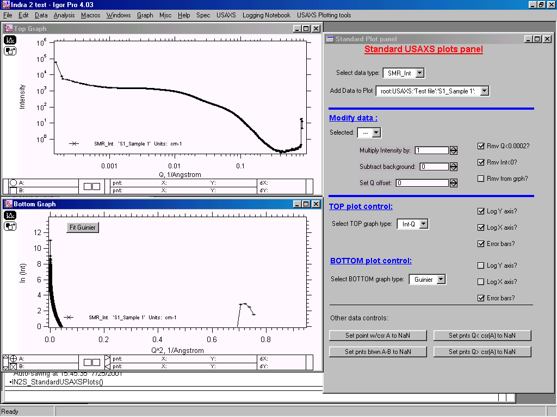
Any graph can be now zoomed using standard Igor graph control. The button in the Guinier graph fits Guinier fit between the cursors and transfers the fit in the other graph, assuming that graph is Int-Q:
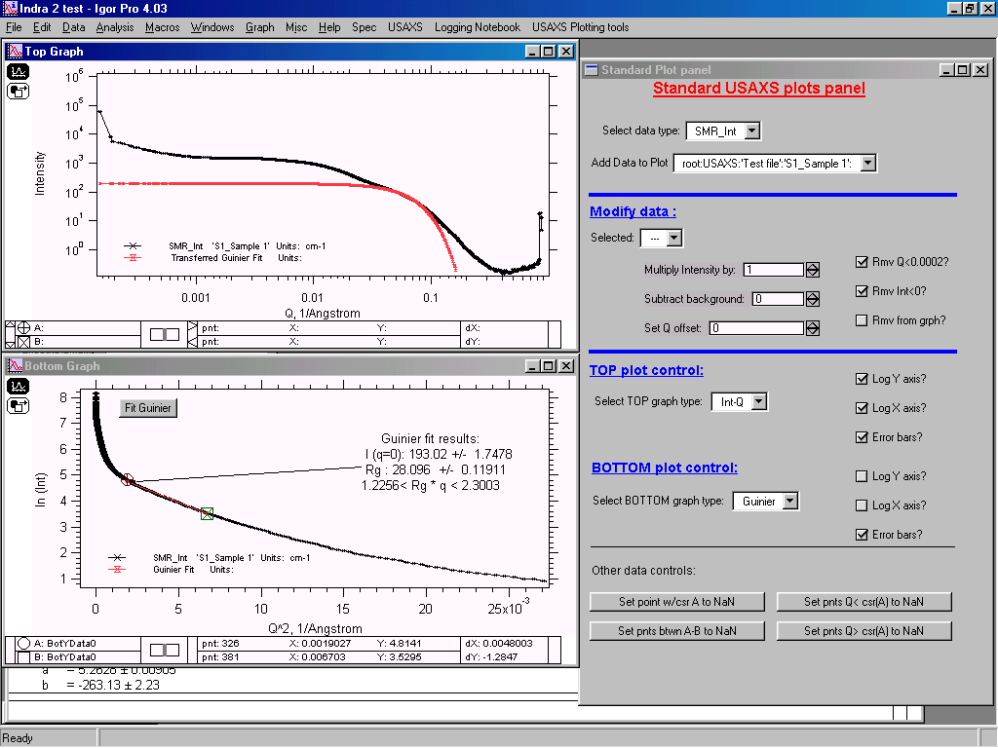
Same behavior exhibits Porod line fitting in the Porod plot. This serves as useful check to verify, if the Porod/Guinier dependence is fitted properly.
Note, that while the tool will happily fit Q⁻³ Porod dependence for smeared data (SMR) as well as proper Guinier dependence for SMR data, it is VERY ADVISABLE TO USE DSM DATA!!! Especially the Porod region usually extends over the area where Q~slit length and the Porod slope changes from Q⁻³ to Q⁻⁴.

To demonstrate mathematical modifications, lets add more data (Sample1 measured second time) and zoom on the Int-Q plot…
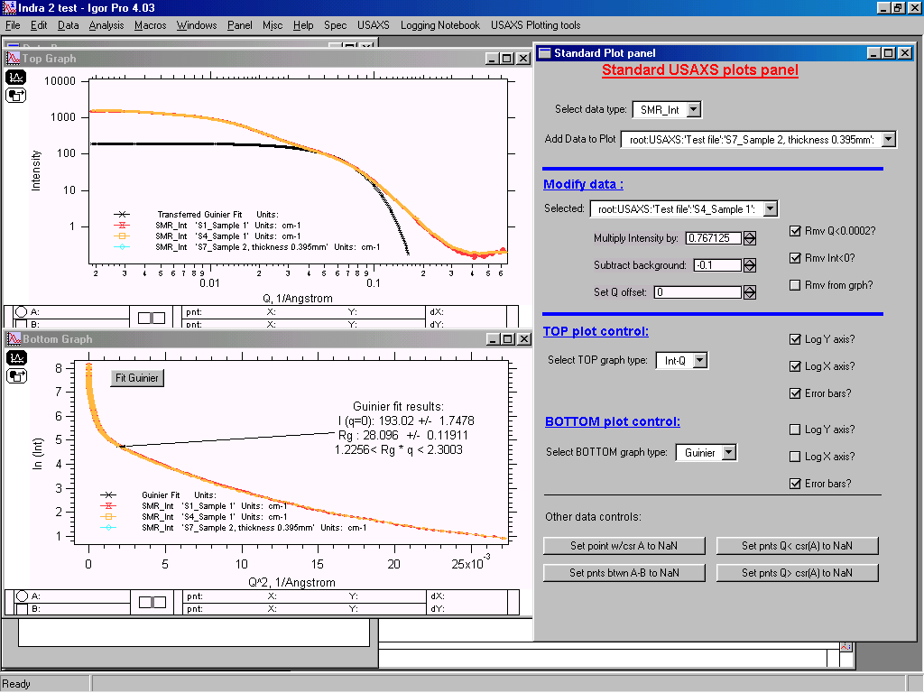
Note, that to overlap the data in the graph we needed to take S4_Sample1 dataset and multiply it by about 0.8 and add some background (subtract negative background)…

I strongly suggest to play for short time with this tool and verify it’s behavior. It is complex tool and the behavior is more issue of my feeling of what is expected behavior than of anything else… If there are features, which need to be added or changes, it is actually quite easy, since this tool is nicely modular and has should be possible to change it simply and easily…

Just a comment at the end. The macro recalculates all the data in the graph every time any change is done to any dataset. Therefore more datasets are displayed, slower it will be. On slower machines this tool may become sluggish.

Generic plotting tool for power users
This tool can generate “generic” plots – i.e., plot any waves against any other wave in the folder. It also allows to add error bars. The tools is very easy to use, even though it may be cumbersome in data selection.
First select data folder with the data to be plotted. Data folders under root:USAXS:, root:raw:, and root:Others: are shown.
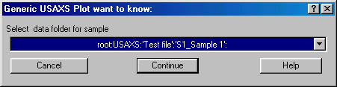
Next select waves to be used for Y axis, X axis and error bars – and select the type of axis (combination of log or linear). An example is :
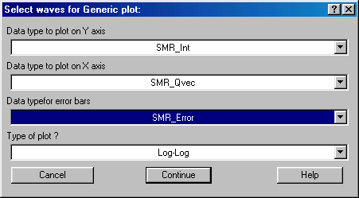
Continue.
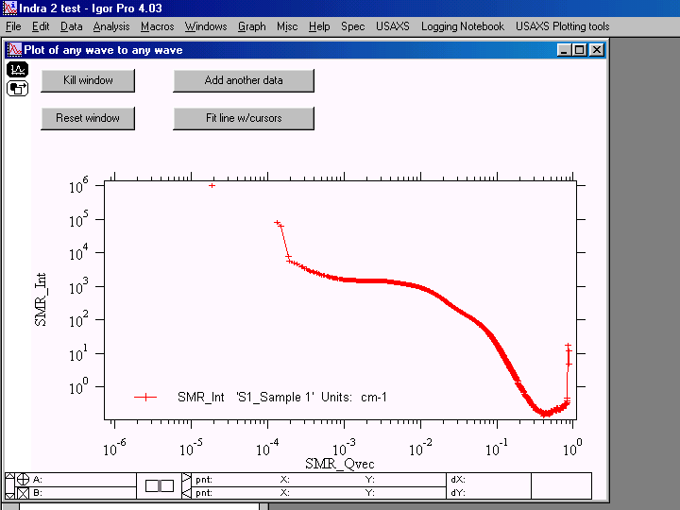
This is the graph which is produced. It is possible now to add the SAME combination of waves from another folder. The graph can be manipulated using the Igor graph modification tools…There is nothing more to it. When done, push button Kill window.

Standard USAXS plots
This tool produces standard USAXS related plots in less cumbersome way of data selection than the Generic plots. The pitfall is that it is limited to plotting only the data which I have coded in. It is predecessor of the Standard USAXS plot tool discussed above.
First select the data type and type of plot:
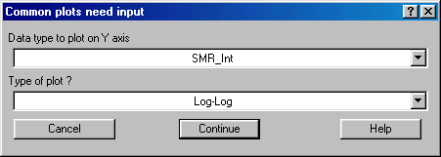
Next select the datafolder with data you want to plot. Note, that only the folders in root:USAXS: with the data type selected above are listed:
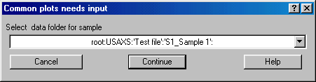
And the graph is here:
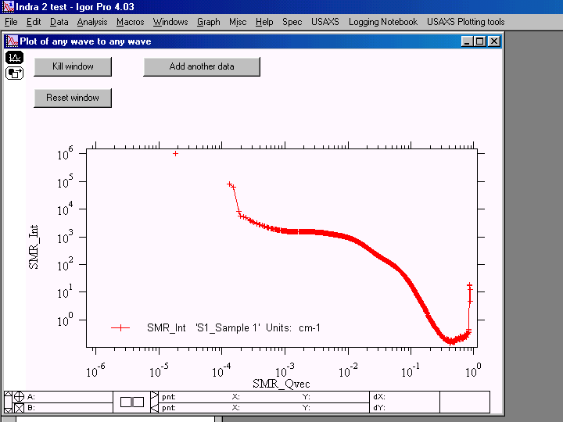
The graphs is very similar to the previous tool. Again, kill graph when finished with this tool.

Other tools
Other tools are some fitting tools in the “USAXS Plotting tools” menu.

Draw line of xxx slope - bunch of simple tools which draw line with various slopes in the log-log graphs. Very useful to test quickly, if data follow some particular slope.

Make log-log graph decade limits – makes limits of the log-log graphs to be nicer. Very simple.

Fit line with cursors & Fit Power law with cursors – very useful two macros. Put cursors in the graph and select the menu choice. Line is fitted and label with the result of the fit are attached to the fitted line.

Comment: These tools were modified from tools of a colleague. If you know about any other small useful tools, please forward them to me with explanation of what is expected etc… If possible I’ll be happy to modify and include them in these macros.

Channelcut calculations
During USAXS alignment it is necessary to perform some calculations about the channelcut dimensions – particularly about the spacing between the two crystals – to obtain particular number of reflections. The small piece of code included in Indra2 macros – “USAXS” – “Xtal gap calc” – provides interface for these geometrical calculations.
The code should be flexible enough to handle any channelcut for Si 111 and Si 220 at any energy. The interface provides easy way to input proper numbers, as it is graphical:
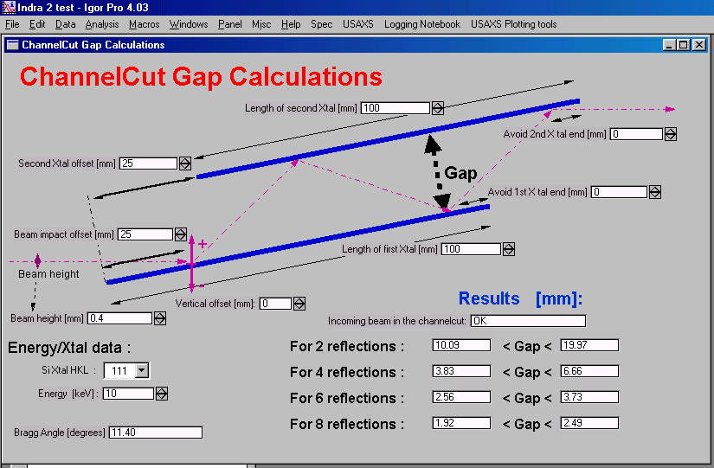
Note, that input values are Si Xtal type (111 or 220) and energy – Bragg angle is calculated – and dimensions of the crystals in separated channelcut. The results are the ranges of gap in which one can expect 2, 4, 6, and 8 reflections to pass through the channelcut.
Anyone is encouraged to use this code – and if possible to verify it. From our experience the results seem to agree with the reality.

Various other parts of code

Multiple small angle correction
In case of samples with multiple scattering, the beam height in the center is no longer appropriate indicator of the sample transmission. To be able to recover calibration we need different tool to measure the sample transmission. In such case we revert to standard SAXS & SANS method, when the peak intensities for sample and blank are integrated over reasonable Q range and intensities are then compared.
To keep compatibility with the standard USAXS macros, however, the MSAXS correction macro is standalone step in data evaluation. However, to indicate, that the data were corrected for MSAXS, new wave names are user : M_SMR_Int (etc.) for smeared data and M_DSM_Int (etc. for Qvector and errors).
First the sample is evaluated without the MSAXS correction and SMR (smeared) waves are created (i.e., Subtract sample and blank is finished).
Then the “USAXS” – “MSAXS correction” is run:
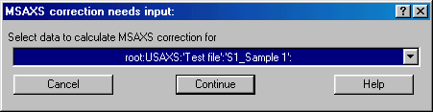
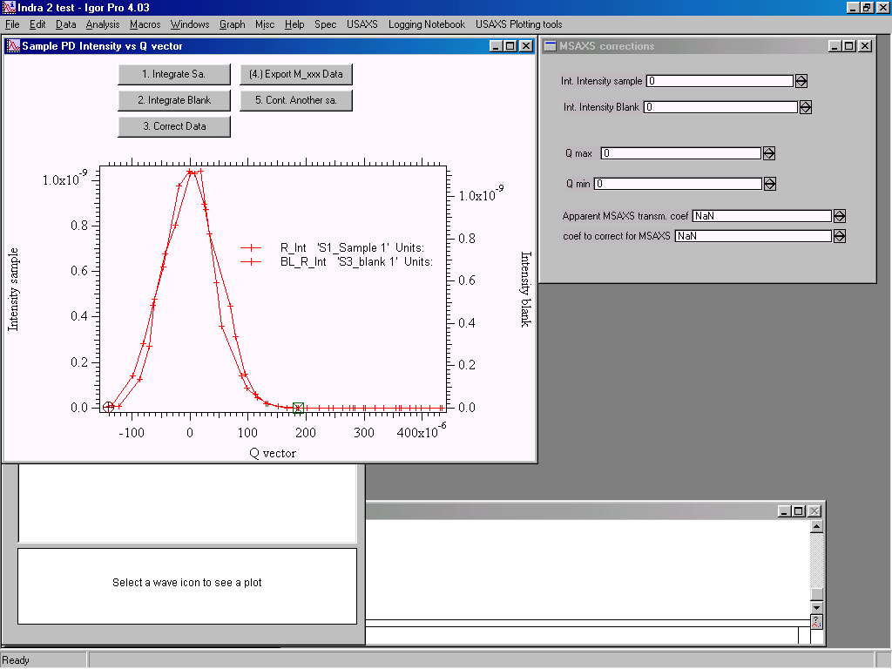
This graph shows the R-waves for sample and blank overlayed (after correction for standard transmission). These two measurements do not show significant multiple scattering component, but for the sake of this example lets do this correction – it should come up with factor close to 1…
Select area of Q vector with cursors. It is usual, that there are not enough data on the left hand side, so the missing Q range on the left hand side is taken from the right hand side. Now follow buttons with numbers: Integrate Sample(1) and Blank (2). The panel on the right hand side shows results as well as apparent MSAX transmission coefficient and MSAXS correction – this is here coefficient needed to be applied on SMR data to get proper transmission. Note that no change is made to SMR data, new dataset M_SMR is created. All follow up macros can handle M_SMR and M_DSM data similarly to SMR and DSM data. Major problem arises only when M_ xxx and xxx data need to be compared together in plots as currently no plotting tool supports mixing the data types…

Anisotropic MSAXS correction
This is specifically needed function for SBUSAXS. Who is not using this setup, stop reading here…

Function generates panel which allows user to run steps as needed. The function generated few waves in the MSAXScorrection folder. These are Folders, Transm, FWHMcorrection, Weight and Correct. User can freely edit them (and is asked to do so). Separate single MSAXS correction routines need to be run (Called from the panel) for each measurement sector. These generate record in the Waves mentioned above. Panel allows reseting of these waves. After all sectors are calculated, user needs to modify the Weights and Correct as needed.
Weights use:
Weight =0 causes the sector to be neglected in calculation altogether, any weight higher than 0 is used multiply the transmission in that sector for calculating average. The sum of weights is normalized out, so the values in weight are somehow unimportant really… Their ratio is the important part, I use either 1 for all sectors (if these are same width) or the actual width of each sector in degrees…

The overall correction factor is actually average of the “integral transmissions” multiplied by ratio of FWHM of sample and blank peaks. These are weight-averaged and the “corrected transmission” of sample is produced. This is used further.

When being corrected, any folder with Correct=0 is skipped… Any non 0 number is corrected for average Transission generated from the AnisoMSAXS calculations…

Merge two datasets
This macro has not been tested in real work applications. In principle it is here to allow working with separated angular range measurements – usual way in early days of USAXS measurements at X23 ant NSLS. At that time the data were obtained in subsequent measurements by measuring different angular ranges with different angular steps. At that time it was not possible to change angular analyzer step during measurements. So each sample was measured in few (~4) separate measurements which were then combined together. It is possible to imagine need for this routine today, so I have coded it in… I already forgot how to sue it, and no one ever needed that. If anyone ever needs it, I’ll be more than happy to check it and make it useable – and documented here… For now it looks as lost time for me…

Grazing angle USAXS
This is code under development and even I have very little understanding of the math behind it. Do not use it – or if you understand, help me to verify the code and improve on the method…

Mathematics of the code
The proper math is in separate file. This one may n

This chapter briefly shows the mathematics, which the code uses. This math was pulled directly from the code, so it should reflect the reality. It is amazing, how little math the code really does…
R wave

Function IN2A_CalculateRWave(df)

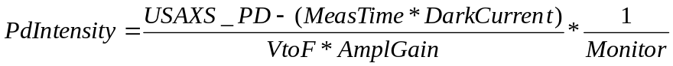

Now error calculations, general problem:

SigmaUSAXSPD=sqrt(USAXS_PD*(1+0.0001*USAXS_PD))
//this is our USAXS_PD error estimate, Poisson error + 1% of value

SigmaPDwDC=sqrt(SigmaUSAXSPD^2+(MeasTime*ErrorParameters[pd_range-1])^2)
//This should be measured error for background

SigmaPDwDC=SigmaPDwDC/(VToFFactor*LocalParameters[pd_range-1][0])

A=(USAXS_PD)/(VToFFactor*LocalParameters[pd_range-1][0])

//without dark current subtraction

SigmaMonitor=sqrt(Monitor)

SigmaRwave=sqrt((A^2*SigmaMonitor^4)+(SigmaPDwDC^2*Monitor^4)+((A^2+SigmaPDwDC^2)*Monitor^2*SigmaMonitor^2))

SigmaRwave=SigmaRwave/(Monitor*(Monitor^2-SigmaMonitor^2))

PD_error=SigmaRwave

This is our complex and only approximate formula for the error, but do not have better.

Function IN2A_FitLorenzianTop
K0=0
CurveFit/H="1000" Lorenzian with baseline fixed to 0
Baseline=W_coef[0]=0
BeamCenter=W_coef[2] [degrees]
MaximumIntensity=W_coef[1]/W_coef[3] [counts]
PeakWidth = sqrt(W_coef[3])*2 [degrees]

Function IN2A_FitGaussTop
K0=0
CurveFit/H="1000" Gaussian with baseline fixed to 0
Baseline=W_coef[0]=0
BeamCenter=W_coef[2] [degrees]
MaximumIntensity=W_coef[1] [counts]
PeakWidth = W_coef[3]*2*ln(2) [degrees]

Function IN2A_CreateLogLogPlot()

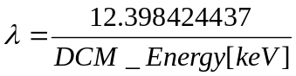 [A]

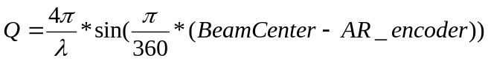 [A⁻¹]

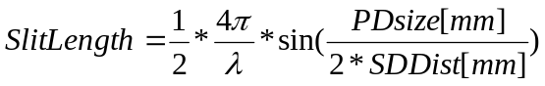 [A⁻¹]

Subtract blank from sample

USAXS calibration

[arc seconds]

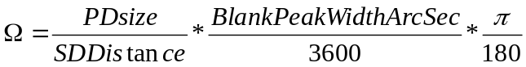

, 0.1 converts the sample thickness from mm to cm.

SBUSAXS calibration, width given by rocking curve width

AsStageWidth is assumed to be same as BlankPeakWidth, user can overwrite both values.
comment: it seems, that proper DSM calibration should include factor of 1.53(?) to account for the use of single bounce sidebounces…

, 0.1 converts the thickness from mm to cm…

No calibration

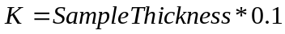
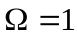

Corrections for transmissions and peak shift for Subtract Sa & Blank

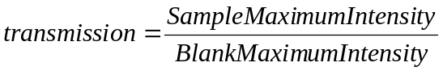

USAXS

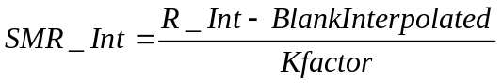

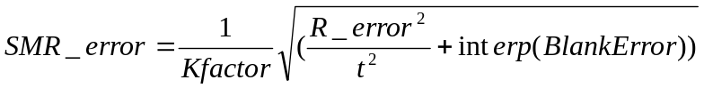

SBUSAXS - create DSM data

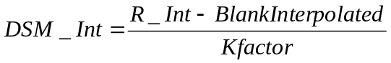

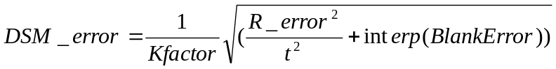

Note, that the Q shift is shifting the sample data with respect to blank, which is considered fixed…

MSAXS correction

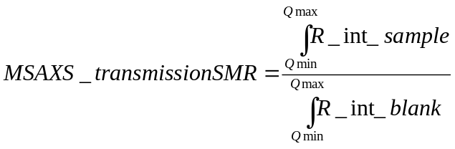

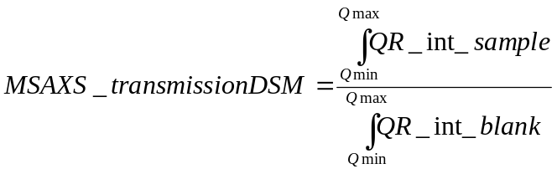

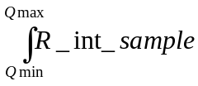,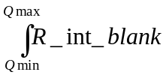,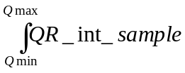,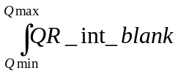 use Igor areaXY function, which uses trapezoidal function. The missing Q range on the “short” side is replaced by range from the other side…

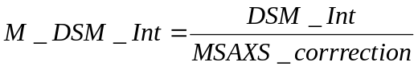
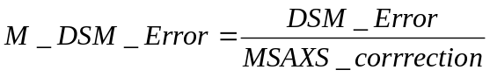
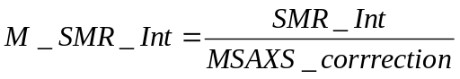
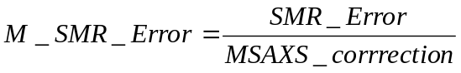

Anisotropic MSAXS problem:

Evaluate all anisotropic data for all sectors, the results are stored in the waves (numeric “MSAXSResults” and text “MSAXSFolder”, both in root:Packages:MSAXSCorrection). These waves can be edited before the correction is applied…
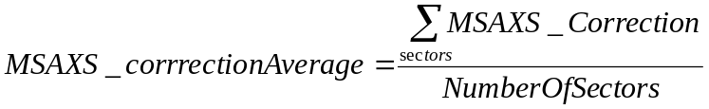
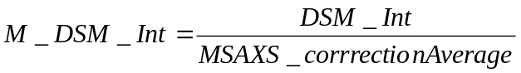
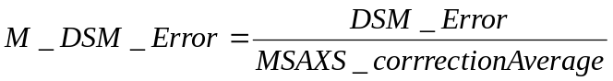

Final comments

This code is under continuing development. I encourage anyone interested in using this code to get in touch with me. It will help me to develop better and more useful code.
Bits and pieces of the code may be in the future used separately. I will at some point make generic versions of specialized macros available and distribute it through web page, which I am in the process of creating.

